**OFFICIAL INTERNATIONAL PUBLICATION OF THE ASSOCIATED LOCKSMITHS OF AMERICA, INC.**

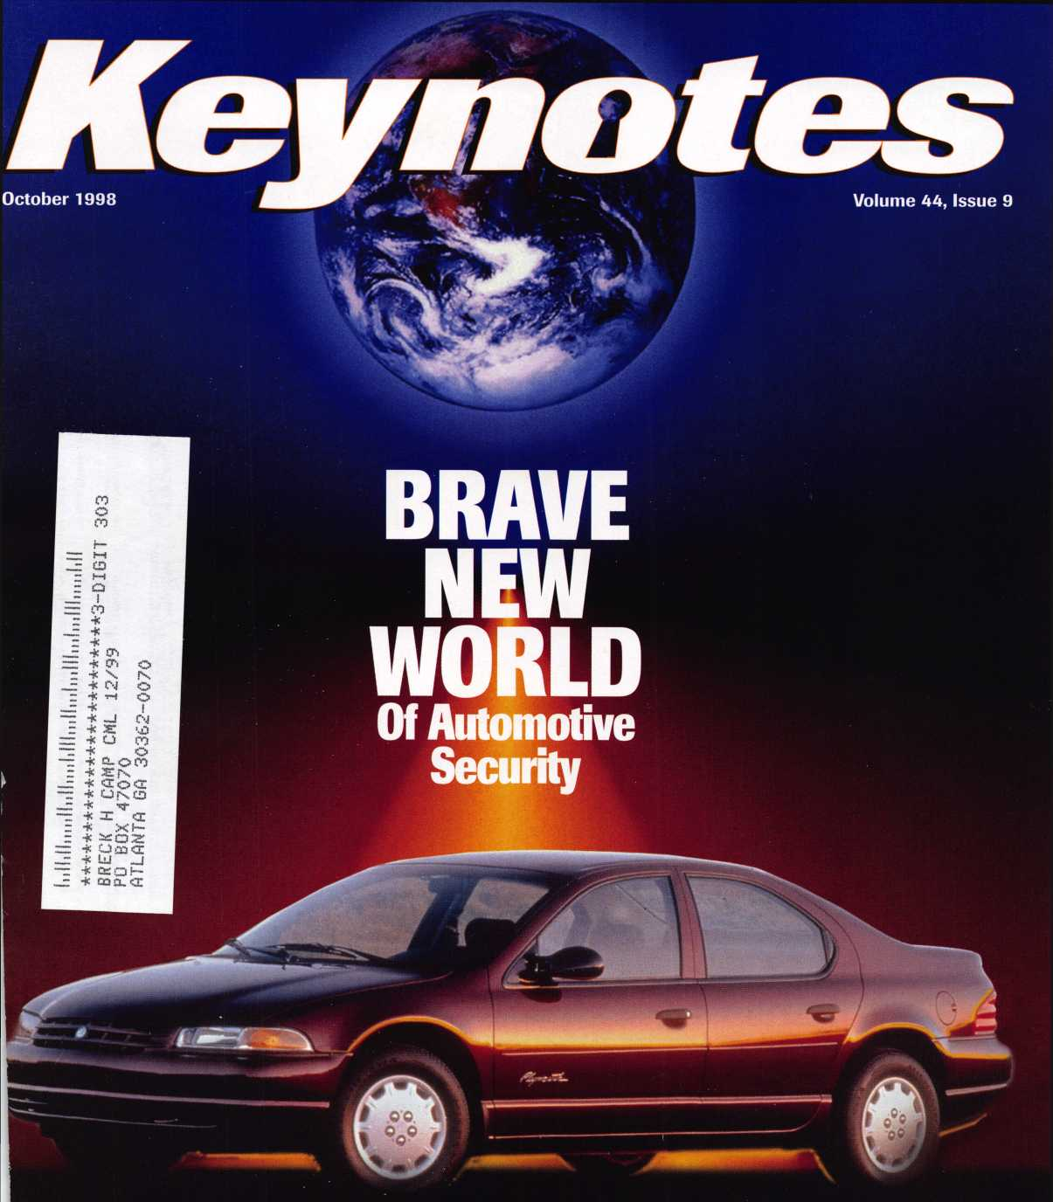

In This Issue:

**The Next Generation of Ignition Technology**

**Software and Hardware of the Future...Today New Business Angles for Automotive Locksmiths**

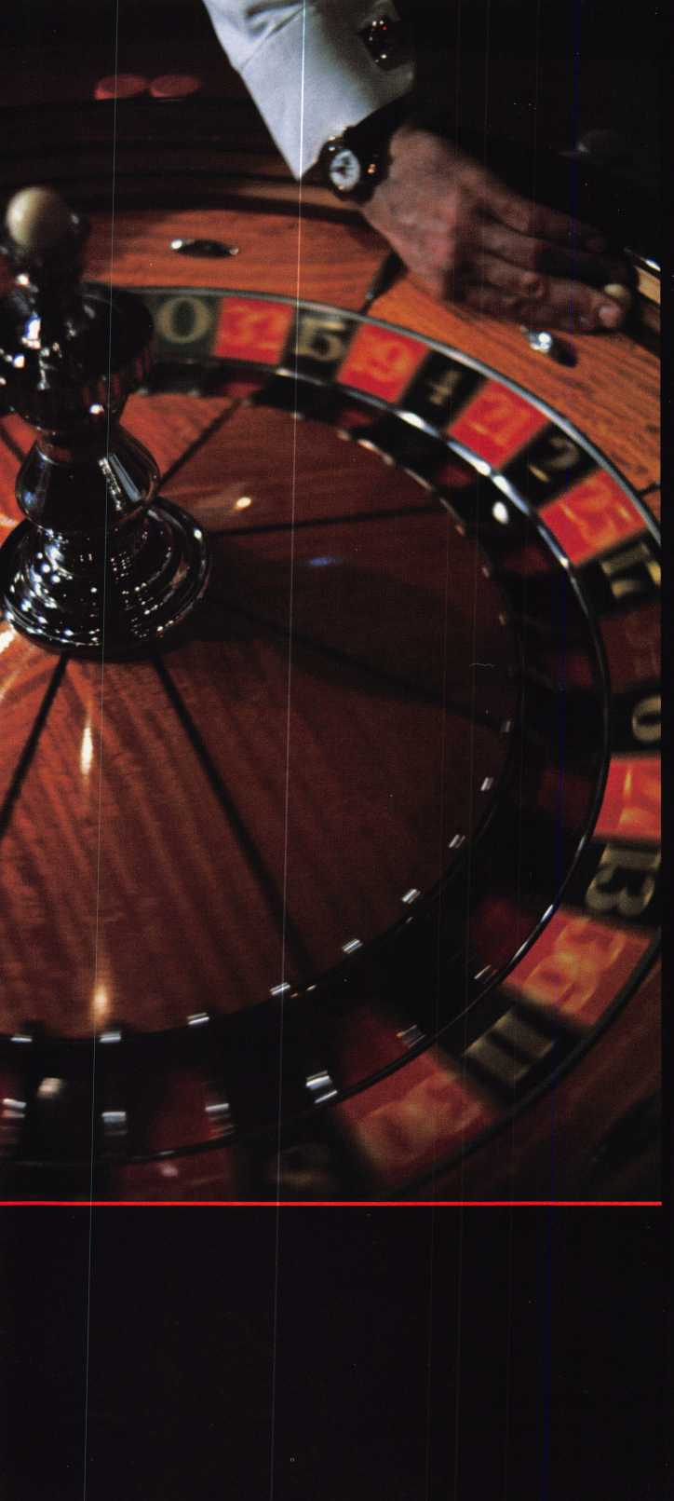

I

You wouldn’t dream of leaving your success  
to chance. You know that making it in the safe  
and vault industry requires hard work, continual  
improvement of techniques, and constant research  
of the latest products and tools.

Your best bet to excel in all these areas is  
SAFETECH ’99 where you can save your luck for  
the casinos, and get down to business viewing  
the latest products, talking with the manufacturers,  
and training in the latest methods of safe and  
vault technology.

Make your plans now to attend SAFETECH ’99  
May 4-9, 1999 in Las Vegas, NV.



**LAS VEGAS, NV * MAY 4-S**

Contact:

Safe and Vault Technicians Association

3003 Live Oak Street  
Dallas, TX 75204  
214.827.7233  
214.827.1810 fax  
email: [convtion@anet-dfw.com](mailto:convtion@anet-dfw.com)

HSNpn

IMMi

**You could win this ITL 950- worth $2,250!**

**The early bird gets the ITL950**

Wise ALOA members who pay their dues before January 1,1999 will receive even more than another year’s valuable membership in their professional association. They’ll be included in a drawing to win this revolutionary code machine donated by Intralock Tools Ltd. the ITL950—a $2,250 value*

For more information about the ITL950 contact Intralock Tools Ltd. by phone at 888.264.6627 or write to 2639 Progressive Way,

Unit B, Abbotsford, BC, Canada, V2T 6H8.

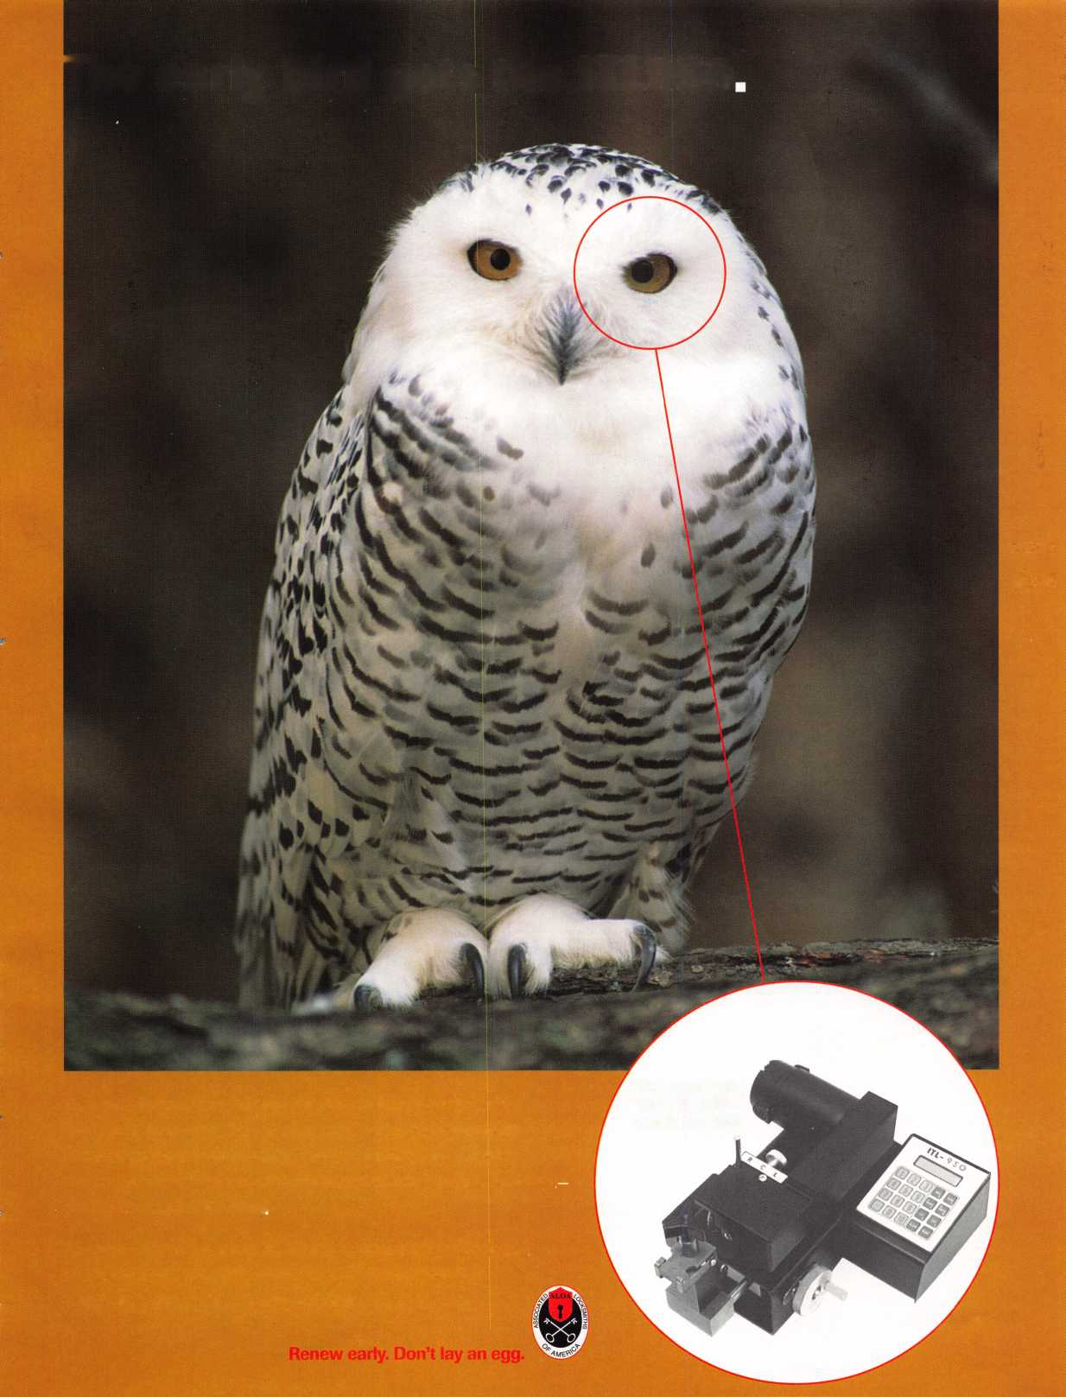

Features

President's; Journey

Make the system work.

By Dallas Brooks

16

**Ontnhftr**

Auto Lock Tools

Sieveking Products offers the Clamp-King,

the E-Z Pull, the the No-Pick GM Glove Box Tool

and the Universal Wafer Lock Reader.

By Sal Dulcamara, CML

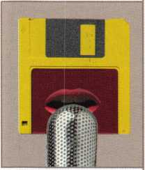

19

Government Affairs: Working Hard For You

Here’s an overview of what went on with ALOA, locksmiths and the legislative process since January.

By Tim McMullen

20

AutoTei Tells All

Check out this brand new software that offers a vehicle database covering most import and domestic automobiles.

By Sal Dulcamara, CML



22

High-Tech Ignitions

More than half of all vehicles to be built in the model year 2000 plan to use what has been called the ‘next generation in automotive security.’ Be ready.

By Fred Kosloske

25

The Chiysler 8-Cut Kit

BWD Automotive is coming out with a service kit for the new 8 tumbler sidebar ignition locks.

By Sal Dulcamara, CML

The Cover:  
With more vehicles on  
the road than ever before,  
the technology protecting  
the buyer’s investment is  
evolving yet again. Are you  
equipped to ride the fast lane  
of the booming automotive  
security market?

26

The Other Automotive Customers

While the general public is a good customer base,  
locksmiths who wish to increase their auto lock servicing  
and sales must pursue automotive trade customers who  
are buying their parts from new car dealers.

By Buddy Logan

28

GM Progression 101

Art direction/design ~ , -»«- , . . ,

” The General Motors progression technique is the most Valerie Rowe , c , , , c i

common and most useful method for generating an original

key when there is no existing key or code information.

By Steven B. Spiwak, CRL

31

Common Mistakes

When Managing Part-Time Workers

How do you motivate employees who may feel like “outsiders”?

By Phillip Perry

October 1998



Mail Box

Problems with customer service.

Applicants for Membership Scheduled for clearance Nov. 1

**ents**

**Volume 44, Issue**

8

Upcoming Events

ACE classes at MINK and Tri-Regional.

10

Security Marketplace More new auto products.

12

Core

American Lock acquired, Defiant Safe consolidated and Sieveking offers a new reference for domestic autos.

41

Trade Tips News from TLA.

42

Authors in This Issue

44

Back Page

34

Associate Members

38

Classifieds

40

Buyer’s Guide

40

Ad Index

**J** Keynotes

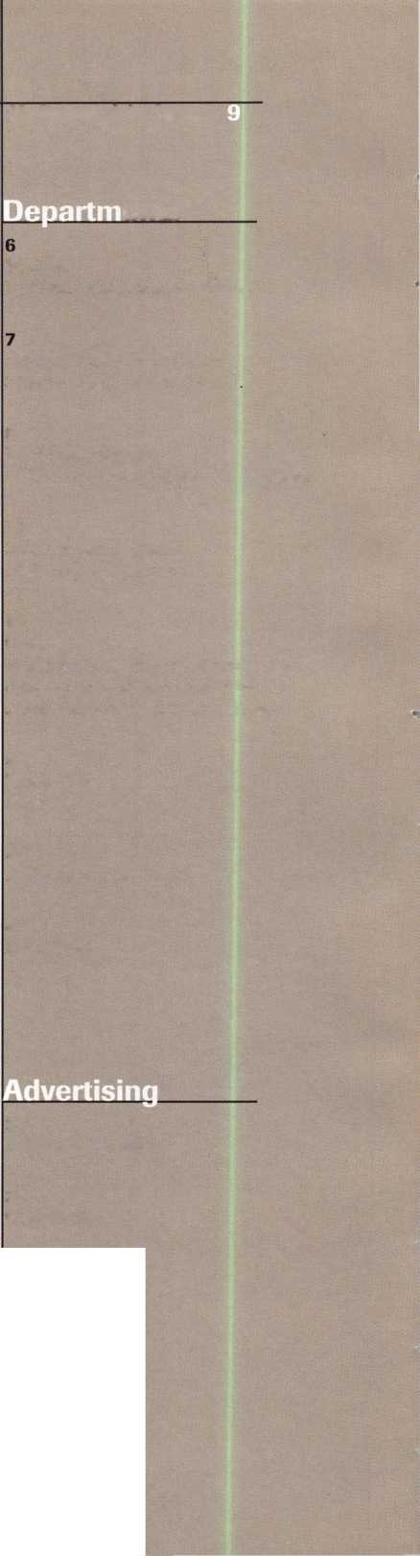

|  |  |
| --- | --- |
| Editor | Anne McDonald Davis, ABC [keynotes@anet-dfw.com](mailto:keynotes@anet-dfw.com) |
| Associate Editor | Mike Emery keynotes @anet-dfw.com |
| Technical Editor | David Lowell, CML, CMS [david@aloa.ioffice.com](mailto:david@aloa.ioffice.com) |
| Editorial Advisor | John D. Cannon, CML [jdcannon@worldnet.att.net](mailto:jdcannon@worldnet.att.net) |
| Advertising Sales Manager | Anelia M. Banda  anelia@aloa. ioffice .com |
| Sales Assistant | Sally Guereca |
| Contributing Authors | Jerome V. Andrews, CML Paul Chandler, CRL  Claire Cohen, CML  Brian Costley, CML, CMS Bob De Weese, CPL  Ray D’Adamo, CML  Sal Dulcamara, CML  James Glazier, CML  Daniel Graffeo, CRL, CMS Wayne Gurnee, CRL  A.J. Hoffman, CML  Ken Holmlund, CRL  Ray Lusk, CML  Mark Ohno  Randy Simpson, CML  Steven Spiwak, CRL  Robert Stafford, CPL  Dave Thielen |
| ALOA Professional Staff | |
| Executive Director | Charles W. Gibson, Jr., CAE charlie@aloa. ioffice .com |
| Operations Manager | Mary May  [mary@aloa.ioffice.com](mailto:mary@aloa.ioffice.com) |
| Receptionist | Margo E. Vela |
| Comptroller | Kathy J. Romo |
| Meetings Manager | Jessica Vasquez [jessica@aloa.ioffice.com](mailto:jessica@aloa.ioffice.com) |
| Meetings Assistant | Janelle Vergara |
| Government Affairs Manager | Tim McMullen [tim@aloa.ioffice.com](mailto:tim@aloa.ioffice.com) |
| PRP/Education Manager | David Lowell, CML, CMS [david@aloa.ioffice.com](mailto:david@aloa.ioffice.com) |
| Education Assistant | Ashley Spencer |
| Membership Coordinator | Brandon Durrett [brandon@aloa.ioffice.com](mailto:brandon@aloa.ioffice.com) |
| Membership Assistant | Jackie Arnett |
| Chapters & Regional | |
| Associations Liaison | Tim McMullen [tim@aloa.ioffice.com](mailto:tim@aloa.ioffice.com) |

Executive

Additional contact information for the ALOA Board and most Keynotes authors are available through "Locksmith Search ” on the ALOA website- [www.aloa.org](http://www.aloa.org) or by contacting the ALOA office at 3003 Live Oak Street; Dallas, TX 75204; [214)827-1701; FAX [214) 827-1810; e-mail [aioa@aioa.org](mailto:aioa@aioa.org).



Mission Statement: The Associated Locksmiths of America, Inc. is dedicated to enhancing the professionalism, education and ethics among locksmiths and those in related sectors of the physical security industry. With approximately 10,000 members in the United States, Canada and the freeworld, ALOA is poised to help members obtain the knowledge, the strength, and the confidence to perform their role in the physical security field with pride and dignity. But it is only through active involvement and participation that ALOA can fully achieve its potential-and can help members to achieve theirs.

Policies: Keynotes® is the official publication of the Associated Locksmiths of America, Inc. (ALOA). Keynoted* acts as a moderator without approving, disapproving, or guaranteeing the validity or accuracy of any data, claim, or opinion appearing under a byline or obtained or quoted from an acknowledged source. The opinions expressed by the authors do not necessarily reflect the official views of ALOA. Also, appearance of advertisements and new products or service information does not constitute an endorsement of products or services featured by the Association. The Association does not accept responsibility for the inaccuracy of any data, claim, or opinion appearing in this publication, due to typographical errors on the part of the authors. Association staff or its agents. Editor’s Note: This publication is designed to provide accurate and authoritative information in regard to the subject matter covered. It is provided and disseminated with the understanding that the publisher is not engaged in rendering legal or other professional services. If legal advice and other expert assistance is required, the services of a competent professional should be sought.

Authors’ Payment: Payment for eligible submissions to Keynotes will be based on the following criteria: topic, time spent and past contributions. Authors who regularly submit to Keynotes are generally paid a higher rate. The latter is especially true of authors who write to fit specific editorial needs and submit said copy by Keynotes deadlines. As a general guideline: Average payment for a 750 word, business or ‘light’ technical article would be $200. Payment for a 1500 word article involving significantly higher time and research efforts would be $400.

Payment will not be offered for articles submitted by ALOA employees or members of the ALOA Board of Directors [unless material is of a technical nature], nor for articles submitted by a company that promote that company’s products or services. ALOA reserves the right not to pay for articles submitted by an individuals] that promote a particular company’s products or services.

Disclaimer: The Associated Locksmiths of America, Inc., [ALOA], reserves the right to refuse any article for any reason. Additionally, ALOA reserves the right to edit, amend or modify any article submitted for publication in order to preserve technical accuracy, clarity, fairness or grammatical correctness. ALOA will make the best efforts to notify the author of any changes. The extent of ALOA’s liability for any article or information contained therein will be a notice of correction or retraction in the next possible issue.

Keynoted1 (ISSN 0277 0792] is published monthly except for the combined June/July issue by The Associated Locksmiths of America, Inc., 3003 Live Oak St., Dallas, TX 75204-6186. Telephone: [214] 827-1701; FAX [214] 827-1810; e-mail [aloa@aloa.org](mailto:aloa@aloa.org). Subscription rates for members-$15.00 per year. Second class postage paid at Dallas, Texas. POSTMASTER: Send address changes to: Keynotes, 3003 Live Oak St., Dallas, TX 75204-6186. © Copyright 1998, All rights reserved. No part of the contents may be reproduced or reprinted in any form without prior written permission of the publisher.

**Board**

President

Dallas C. Brooks [334] 826-8990

Regional Vice Presidents Southeast

♦Jeffrey S. Nunberg, CML, CMS

[305] 324-8800

North Central

♦John J. Greenan

[773] 486-2030

South Central

♦Randy L. Simpson, CML

[713] 780-7026

Southwest

John I. Shandy, CML

[303] 776-7898

Northeast

James H. Glazier, CML

[301] 831-5454

Northwest

Raymond C. Lusk, CML

[509] 624-3152

Secretary

John D. Cannon, CML

[703] 960-6413

Trustees:

David M. Lowell, CML, CMS [214] 827-1701 Breck H. Camp, CML [770] 455-6244 Henry H. Printz, CML [201] 538-2737 Leonard J. Passarello, CPL [416] 752-7210 Edwin Toepfer, RL [416] 225-5589 Directors

*These officers also serve as directors.

Dana L. Barnum, CML

[610] 565-9900

Mark E. Blum, CML, CPS

[517] 482-5809

AJ. Hoffman. CML

(714J572-6008

Barry K. Leas, CRL

[610] 650-9292

Clyde Roberson, CML, CPS

[540] 380-5000

Donald E. Rul6. CML

[601] 324-2658

Anthony J. Ramunno, CML, CPS

[330] 782-6204

Robert H. Stafford, CPL

[860] 768-7917

Bruce J. Tarbet, CML

[601] 924-4184

Chairmen of International Affairs

Laurence P. Mills/Australia [129] 958-0445 Hans Mejlshede, CML/Europe FAX [453] 139-1004 Members-at-Large Jerome V. Andrews, CML [860] 621-3601 Steven G. Engel, CML, CPP [414] 731-5400

Past Presidents

1995-1997 David Lowell, CML, CMS 1993-1995 Breck Camp, CML 1991-1993 Henry Printz, CML 1989-1991 Evelyn Wersonick, CML, CPS 1987-1989 Leonard Passarello, CPL 1985-1987 Joe Jackman, CML 1983-1985 Stanley Haney, CPL 1981-1983 Louis LaGreco, CPL 1979-1981 John Kerr, RL 1977-1979 Clifford Cox, CML 1974-1977 Charles Hetherington 1972-1974 Gene Laughridge 1970-1972 William Dutcher, RL 1968-1970 Constant Maffrey, RL 1966-1968 Harold Edelstein, RL 1964-1966 William Meacham 1962-1964 Robert Rackliffe, CPL 1960-1962 Edwin Toepfer, RL 1956-1960 Ernest Johannesen

October 1998

Keynotes

President’s Journey

a

As I am writing this, the first ever ALOA board election by mail in-proxy  
ballot is taking place. The ballots are being mailed this week. I would like to  
assume, as you are reading this, you are saying to yourself, “Yes, I received my  
ballot, cast my vote, and mailed it in!”

I am counting on you, the members to make this process work. Some skeptics  
have predicted to me this last week that we will not get back more than 200  
ballots. I sincerely believe they are wrong. I am predicting at least a 20 percent  
return, which would mean approximately 1700 ballots returned in the mail. I  
will be highly disappointed at anything less. There were many reasons why  
ALOA has only averaged a couple of hundred members at it’s annual  
membership meetings but what would be your reason for not participating in  
the election of your Board of Directors now? I can not think of many reasons  
unless it is just down right apathy and ALOA will have a hard time surviving in  
the future if much of that exists. I do have faith in my fellow locksmith brothers  
and sisters, I hope you do. The election results will be tabulated and announced  
very soon and you will then have your first ALOA Board ever elected by a  
mail-in ballot!

It will soon be time for another legislative season to begin in most states,  
which means it is time for you to pay careful attention to Tim McMullen’s recap  
of legislative activity around the country. This can be found in every issue of  
Keynotes, this month see page 19- It is very important that you stay informed on  
laws being introduced in your state that can affect your industry.

It is also nearing that time of year that you receive your ALOA dues billing.  
This year you might want to consider mailing your dues payment in earlier than  
usual. There will be drawing from among the early payees for a great prize, a  
ITL950 code machine! I would like to personally thank Intralock for donating  
this machine.

Remember, it’s never too early to make your plans to attend the 1999 ALOA  
Security Expo in Cincinnati, Ohio!

&Lc&<JL

Dallas Brooks ALOA President

Kwok-kei Leung

Henry Raymond

Toshihiro Asano.

Stewart Levine, CML _

Mary Ohmit, CPL

Charles Robertson, CML__ Yuriko Yanai _____ Jack Hobin, CPL

Allen Konrath

Salvatore Dulcamaro, CML

Myeong-Rae Cho

William Neff, CML

Thomas Freehling, CML __

David Lowell, CML

John Heckman, CML _ Jeanne Lodge, CML J. Thomas Hood, CML

Roy Renderer, CML

John Elliott, CML

Danny Rudd, CPL

Larry Warnick, CML

Robert Carroll, CPL

James Watt, CML

Diana Barnum, CRL

Robert DeWeese, CPL

David M. A. Federico

Barbara Watt ______

Jim Williams

Eugene Altobella

Jerome Cohen, CML

Charles Cole, CML

James Fowler, CML

Elvis Hammerschmidt, CPL David Harris, CML D. Michael Lee, CPL John Dorsey, CPL Ronald Heidzig

John Kerr, RL

Marian Swann, CRL

James Cawby, CML_

Joseph Ferrero, CML __

William Grant, CRL

Scott Henke, CRL

Brian Reetz

Michael Robinson, CRL _

Walter Lascar, RL

William McElheney, CML

Philip Rovenolt, CPL __

Gary Teams, CPL

Thomas Vandersteen, CML

James Gruber, CRL

Rex Parmelee, RL

Russell Fuller, CRL

Peter Gauthier, CPL Frank Hartung, CML Edwin W. Scott

Paul Souber

Keizo Takahashi

Best.

|  |  |
| --- | --- |
| Rolando Bouza | 12 |
| James Brickler, CRL | 12 |
| Robert Duman, CML | 12 |
| Jon Griswold, CML | 12 |
| Daniel Landry | 12 |
| Joe Lee, CRL | 12 |
| Lonnie McKinney, CML | 12 |
| Robert Rodocker, CRL | 12 |
| Richard Sievers | 12 |
| Steven Spiwak, CRL | 12 |
| Eric Veal | 12 |
| Herbert Dusenberry, CML | 11 |
| John Engel, CRL | 11 |
| Robin Horsley | 11 |
| Donald Shiles | 11 |
| Lester Brodsky | 10 |
| Thomas Demont, CML | 10 |
| Dale Knowles, CPL | 10 |
| Lawrence F. Smith, Jr., CML | 10 |
| Joseph Whitaker, CPL | 10 |
| William Wickward, CML | 10 |
| Ernest Wright | 10 |

What do I get?

When you recruit 10 members, you receive a handsome blue blazer with a President's Club crest. For each additional five members you recruit, you receive a lapel pin with gold-filled numbers, indicating your recruiting successes.

You also get the satisfaction of knowing that you are helping your association, helping your industry grow, and you are helping fellow locksmiths achieve success.

How do I get started?

Contact the ALOA office for a supply of applications (214) 827-1701 or FAX (214) 827-1810. One President's Club credit is awarded for each new applicant. Credit is awarded only after the membership application is approved. However, the credit will apply for the period in which the application is received. Failure to identify yourself as the sponsor on the application form at the time it is submitted to ALOA for processing will forfeit any credit.

*AL0A Board of Directors not eligible for membership in the President's Club.

How can I join the President's Club?

You can earn membership in this prestigious recruiting just 10 new members for ALOA. *Any ALOA member may participate.

club by



A

Keynotes

Mail Box



Dept

**If you have an opinion to offer on the**

**letter(s) printed in** Keynotes **each month,  
let us know! Submissions to the** “Keynotes  
**Mail Box” department are printed on a  
space-available basis. Write to:** Keynotes  
**Mail Box; Associated Locksmiths of  
America, lnc.;3003 Live Oak Street;**

**Dallas TX 75204; or FAX (214) 827-1810.**

A Few Words on Treskat USA

I would like to warn any prospective buy­ers of locksmithing software about Treskat USA. I have been a user of Codemaster, Key- manager, Automaster and Keywiz for approximately four years. The [Treskat] software is very good but heaven help you if you ever have to talk to Ray in technical support. I have just returned all of his software by Federal Express because, in my opinion, he is the rudest, most obnoxious person I have ever had the misfortune to deal with. I had well over $2,000 invested in this software when I returned it.

When I received update #25,1 installed it on two of my computers before I realized there was a problem with the update. I got an error message telling me to call tech sup­port and that I was in danger of losing my $95 access program. When I called tech sup­port, I got a message telling me that tech support was closed until 2 pm (EST). By the

time I called back, the screen on my laptop had gone blank. When I hit a key to bring the screen back up the message had changed to one that said that I had no access program in the computer. When I tried to explain to him what had happened, I had a very hard time getting in a word edgewise. He then finally said to me, “before you wet yourself what did this other message say?” This was a totally inappropriate question from a cus­tomer service representative. Based upon the form letter he sent me, I am not the only one who finds Ray from Treskat USA hard to deal with.

This is not the first time I have had prob­lems with Treskat USA. In February, I returned my access disk back to them by USPS Certified Mail. On the day my disk arrived in Florida, the mailman was unable to get a signature from anyone, so he put a notice in the mailbox notifying Ray of the letter. As I found out later, when I called

him to find out what happened to my disk, Ray is too busy to go to the post office to pick up certified letters. I had to wait for a month to get the disk back because he couldn’t be bothered to go to the post office. The reason I sent the disk to him in the first place is because the disk was cracked and I couldn’t use it. So, I had an inoperable com­puter for over a month because Ray couldn’t bother to go to the post office.

Is this the kind of customer service, you would like to invest your hard earned money in? I have made reservations to fly to Florida in October to file a claim against Treskat USA in an attempt to recover some of the money I have lost because of Ray’s inability to treat his clientele in any other way than rudely and obnoxiously.

Winston Miller, Owner Miller Lock & Key Service

"Timelocks... the professional's choice when only the best will do!"

Diebold 127R and Mosler 126R

Replacement Movements

FEATURES

/Custom designed to retrofit most Diebold and

Mosler timelock cases

/13 jewel Swiss movements

/Heavy duty gear train

/Beautifully finished plates with cap-

tive mounting screws

/Yale, Kumahira and LeFebure

versions available

Regular Price: $225

Sale Price: $199.95

Sale Ends December 31,1998

o..™,.Uxo„ . i 27 SE 29th Street ♦ Topeka KS 66605 ♦ 888 798 8464 / Fax 800 798 TIME (8463) ♦ 785 232 8705 / Fax 785 232 2603

October 1998

J Keynotes

Reader Service #1

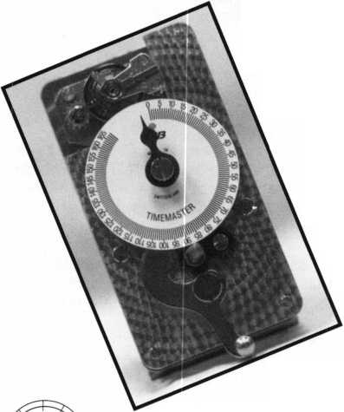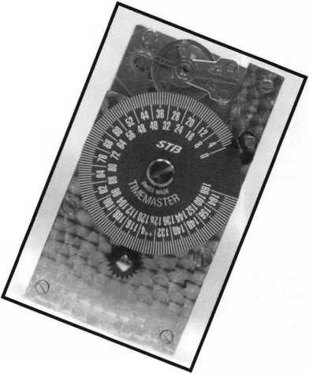

Applicants

For Membership

Dept

*The following applicants are scheduled for clearance as members of  
ALOA. The names are published for member review and comment prior to  
November 1, 1998, to ensure applicants meet standards of ALOA’s Code of  
Ethics. Protests, if any, should be addressed to the Membership Department  
and must be signed. Active Membership applicants (AJ have worked in the  
industry two or more years. Allied Membership (AL) applicants are not  
locksmiths, but work in a security-related field. Apprentice Membership (AP)  
applicants have worked in the industry less than two years. A*

USA

ARMY EUROPE APO

028442, Todd L Howell, AP SPONSOR: Charles Robertson

ALABAMA

Birmingham

028438, Larry E Blackwell, A SPONSOR: Ronald Fowler 028363, Scott T Kervin, A SPONSOR: Mark Casey

Huntsville

028407, Wesely C White, A SPONSOR: Larry Warnick

ARKANSAS

Blytheville

028404, William Wheat, A

ARIZONA

Chandler

028416, Alfred Stevens, A

Glendale

028399, William J Kyslowsky, A SPONSOR: William Lee

Scottsdale

028428, Apollo Ellis, AP

Tempe

028373, Michael A Brennan, A SPONSOR: William Summers 028436, Tom Romaine, AP SPONSOR: John Ilk

CALIFORNIA

Bakersfield

028395, Sheila R Branquinbo, A

Long Beach

028376, Joseph W Contreras, AP SPONSOR: James Marshall

Moffett Field

028422, Christopher G Geary, A

San Rafael

028432, Mark B Carry, A SPONSOR: Leroy Page

CONNECTICUT New Britain

028427, Gilbert F Thetreault, AP SPONSOR: Jon Griswold

DISTRICT OF COLUMBIA Washington

028369, Richard A Ashley, AP SPONSOR: Clarence Wiegel

FLORIDA

Gainesville

028413, Robert N Elmore, A SPONSOR: Jeffrey Kane 028414, Mike Lindsey, A SPONSOR: Jeffrey Kane

Naples

028397, Craig C Mackey, A SPONSOR: Norman Skinner

Palm Bay

028417, John Steckowich, A

GEORGIA

Atlanta

028437, Judi Banks, A

Columbus

028435, Harold S Vaughn, A

McDonough

028434, Edward D Hanes, A SPONSOR: A1 Morris

ILLINOIS

Batchtown

028374, Everett E Friedel, A SPONSOR: Michael Edwards

Berwyn

028375, David J Chmelina, A

Decatur

028441, Donald K Martin, AP SPONSOR: Joseph Schuerman

Lake Zurich

028419, Kenneth C May, AP

INDIANA

Greencastle

028443, Richard W Newnam, A

KENTUCKY

Winchester

028423, Jason B Randall, A

MARYLAND

Baltimore

028440, Charlene F Bennett, A SPONSOR: Michael Jordan

Conowingo

028410, Stephen D Stanley, AP

Frederick

028439, Robert F Mangine, A

MINNESOTA

Blaine

028367, Todd C Meyhoff, AL SPONSOR: A1 Ernst

MISSOURI St. Louis

028411, Robert L Theobald, A SPONSOR: Michael Edwards

MISSISSIPPI

Senatobia

028447, Joanne S McGee, A SPONSOR: Charles Payne

NORTH CAROLINA Mooresville

028445, Ron Pierantoni, AP

NORTH DAKOTA Fargo

028433, Gary L Grandbois, AP SPONSOR: Gregory Dwyer

NEW JERSEY Edison

028366, Carrion Geno, A

Pitman

028405, Brian D Ulrich, AP

NEVADA Las Vegas

028396, Kevin W Forcade, AL

NEW YORK Bohemia

028429, Michael Festa, A SPONSOR: Edward Povinelli

New York

028398, Otto E Gonzalez, A 028381, Marik Peker, A

Staten Island

028420, Alan E Grym, A 028421, Michael K Shanahan, A

OHIO

Columbus

028389, James L Holbrook, A SPONSOR: Charles OBrien

OKLAHOMA

Ardmore

028446, Joe R Genn, A

Norman

028403, Don E Holzberein, A SPONSOR: James Holzberlein 028402, Danny L Morgan, A SPONSOR: James Holzberlein 028401, Cecil R Parker, A

PENNSYLVANIA

Philadelphia

028418, George A Manire, AP SPONSOR: Joe Lee

West Pittston

028368, Ted J Hughes, A

PUERTO RICO Guaynabo

028380, Jorge L Baeze, A

TENNESSEE

Cookeville

028426, Randy Gentry, AP SPONSOR: Ernest Langley

LaVergne

028388, Thomas C Sherwood, A SPONSOR: Samuel Miller

Madison

028387, Cordell K Smith, A

Memphis

028385, Jerry Pardue, A SPONSOR: Charles Payne

Nashville

028430, Gary L Parker, A SPONSOR: Beverley Penney

TEXAS

Dallas

028393, Joseph Nardozza, A SPONSOR: Melissa Sibley 028379, Warren W Stephens, AP

El Paso

028382, James R Williams, AP

Lubbock

028371, James L Latch, AP SPONSOR: Alton Sprawls

UTAH

Brigham City

028400, Michael A Jenson, A

WASHINGTON Bonny Lake

028370, Michael T Buman, A SPONSOR: Gordon Buman

WEST VIRGINIA Princeton

028364, Brian D Wiley, AL

WYOMING

Riverton

028412, Larry C Johnson, A

ARGENTINA

028391, Sergio W Prieto, A SPONSOR: Evelyn Wersonick

AUSTRALIA

Yadeoville NSW

028431, George B Wooll, A SPONSOR: George Ramsay

NEW TERRITORIES Yuen Long

028406, Wong S Siu-Shing, AP SPONSOR: Kwok-kei Leung

COSTA RICA

San Jose

028386, Marco Hernandez, A SPONSOR: Shirley Schamp

ENGLAND

Bristol

028394, Samuel L Allen, A SPONSOR: Tony Mendes

OXFORDSHIRE

Wallingford

028444, Aidan C Shoebridge, A SPONSOR: Paul Souber

SPAIN

Gijon Asturias

028390, Sampedro J Garcia, A SPONSOR: Steve Gallagher

HONG KONG

Shatin

028409, Wing-Fat Lau, A SPONSOR: Kwok-kei Leung

JAPAN

Akita City

028377, Yoshihito Kagaya, A SPONSOR: Kazuhisa Matsunaga

Fukuoka

028450, Shinji Yano, A SPONSOR: Yoshitomo Harada

Hiroshima

028425, Veno Hiroki, A SPONSOR: Takeshi Kato

Ichikawa-City Chiba

028363, Zenzaburo Takano, A SPONSOR: Toshihiro Asano

Kashiwa-City Chiba

028361, Jun Yamazaki, A SPONSOR: Toshihiro Asano

Kitakyushu-City

028378, Satoru Horiuchi, A SPONSOR: Yoshitomo Harada

Oitashi

028408, Tetsuo M Katayama, A SPONSOR: Yuriko Yanai

Shibuya-Ku, Tokyo

028424, Uzuki Fumihiko, A SPONSOR: Yoshizawa Makoto

Tokyo

028384, Wake Noboru, A SPONSOR: John Elliott

OSAKA

Higashiosaka

028449, Yoshio Mizutani, AL SPONSOR: Yuriko Yanai

NEW ZEALAND

Invercorgill

028415, Gary P Rewcastle, A

Manukau City

028372, David R Nicholson, A SPONSOR: Kenneth Lees

URUGUAY

Montevideo

028392, Alfredo P Bianchi, A SPONSOR: Kenneth Griffin

October 1998

Keynotes



**Upcoming**

Events



OCTOBER ’98 1 -2&4

V ". _ POLA Trade Show ’98/

ALOA ACE Classes

Penn Ohio-Locksmiths’ Assoc., Inc.

Independence, Ohio (Cleveland area)

Contact: Martha Eggler

(216) 575-2783

Fax (216) 267-2511

e-mail: [PAL01l6@aol.com](mailto:PAL01l6@aol.com)

3

Mas-Hamilton,

Auditcon System 2100 Course Jacksonville, FL, New York, NY (606) 253-4744 ext. 180 (606) 281-5766 fax

4

San Francisco Bay Chapter of California Locksmiths Assoc.

Ninth Annual Locksmith Flea Market Hayward, CA Centennial Hall, Room 4 Contact: Lee Page (415)479-8879

4

jf* ALOA PRP SITTING Sponsor: POLA Contact: Martha Eggler (216) 676-8464

8-11

SAVTA Fall Board Meeting Las Vegas, Nev.

(214) 827-SAFE (7233)

(214) 827-1810 fax

10

Mas-Hamilton,

Auditcon System 2100 Course Albuquerque, NM,

Lincoln, NB

(606) 253-4744 ext. 180 (606) 281-5766 fax

10

Lock Museum of America 26th Annual Lock Collectors Show Contact: Geri Stuttig (203) 869-6260

10-11

Mas-Hamilton X-07 Certification/Troubleshooting Orlando, FL

(606) 253-4744 ext. 180 (606) 281-5766 fax

12

1998 Vindicator and Vindicator II Course Lexington, KY (606) 253-4744 ext. 180 (606) 281-5766 fax

1. 18

MINK Convention/

V__ ALOA ACE Classes Omaha, Nebraska Contact: Elmer Howard (402) 330-8701 (402) 330-9456 fax

17

Mark Bates Associates Combination Lock Technology III class Nicholasville, KY 40356-1850 Contact: Paula Bates (606) 887-0496 (606) 887-9491 fax

17

Mas-Hamilton,

Auditcon System 2100 Course Chicago, IL, Pittsburgh, PA (606) 253-4744 ext. 180 (606) 281-5766 fax

17

1998 Vindicator and Vindicator II Course Salt Lake City, UT (606) 253-4744 ext. 180 (606) 281-5766 fax

17-19

S. C. Association Meeting Columbia, S.C.

(803) 735-1600

18

Mark Bates Associates Time Locks class Nicholasville, KY 40356-1850 Contact: Paula Bates (606) 887-0496 (606) 887-9491 fax

18

f/ ALOA PRP SITTING Sponsor: MINK Locksmith Assoc. Omaha, NE Contact: Elmer Howard (402) 330-8701 (402) 330-9456

19-25

25 th Tri-Regional Locksmith Conference Portland, Ore.

Contact: Stan Hauer (503) 325-6003 phone/fax

21 - 22

Mas-Hamilton X-07 Certification/Troubleshooting Portland, OR (606) 253-4744 ext. 180 (606) 281-5766 fax

21 -23

ir Yankee Security

Convention/ALOA ACE Classes

Providence, RI

Contact: Robert Mahoney

(800) 209-8266

(860) 646-2122 fax

23

f/ ALOA PRP SITTING Sponsor: Tri Regional Convention Portland, OR Contact: John Kerr (503)253-0424 (503) 520-9072 fax

24

Grand Canyon Chapter GM Airbag and V.A.T.S. class Bostrum High School Phoenix, AZ Contact: Robert Arthur (602) 848-0685

24

Mas-Hamilton,

Auditcon System 2100 Course Birmingham, PA; Dallas, TX (606) 253-4744 ext. 180 (606) 281-5766 fax

24

P ALOA PRP SITTING

Sponsor: Yankee Security Convention

Providence, RI

Contact: Robert Mahoney

(800) 209-8266

(860) 646-2122 fax

29-30

Door and Hardware Institute Forum for the Future: Business Strategies for Electrified Products Orlando, FL Contact: Donna Munari (703) 222-2010 (703) 222-2410 fax

31 - Nov. 2

Door & Hardware Institute Annual Convention Orlando, Fla.

(703) 222-2010

NOVEMBER

8

f/ ALOA PRP SITTING Sponsor: Ohio Valley Chapter Contact: Bob Sutton Dayton, Ohio (937) 836-6127

13-14

Door and Hardware Institute Creation of Education Foundation Dallas, TX

Contact: Donna Munari (703) 222-2010 (703) 222-2410 fax

1. 20

Mark Bates Associates DoD/DoE Combination Locks class Nicholasville, KY 40356-1850 Contact: Paula Bates (606) 887-0496 (606) 887-9491 fax

21 -22

Mark Bates Associates Professional Safe Drilling class Nicholasville, KY 40356-1850 Contact: Paula Bates (606) 887-0496 (606) 887-9491 fax

DECEMBER

5

Grand Canyon Chapter Annual Meeting and Banquet Wyndham Garden Hotel Tempe, AZ 85281 Contact: John Ilk, CRL (602) 921-0123 (602) 425-9566 (after 5 pm)

12

f/ ALOA PRP SITTING Georgia Chapter Contact: Steve Gebbia, CML (770) 455-6242

JANUARY 1999 9

f/ ALOA PRP SITTING Locksmith Security Association Detroit, MI

Contact: Sal Dulcamara, CML (810) 791-5416 (810) 792-4021 fax

***Keynotes***

October 1998

\ Indicates ALOA ACE Class

r Indicates PRP Sitting

FEBRUARY

**9-14**

Texas Locksmiths Association Annual Convention and Trade Show Contact: Jim Hetchler (registration) (830) 606-1727 or Pat Titus (booth space) (210) 649-2166

28

Local Organizations for Continuing Education—South Florida Locksmiths Association/

Florida Latin Locksmiths Contact: Jerri (days) (305) 944- 0469; or Wayne (evenings) (305)252-8355

MARCH

**12-14**

IDN Hardware Sales, Inc.

Security Conference Cleveland, Ohio 44122 Contact: Fred Strasberger, John Kress or Bonnie Weston (800)521-0955

20

f/ ALOA PRP SITTING MLANJ

Contact: Bill Timann (732)424-7827

1. **21**

Cp ACE Class

Sponsor: MLANJ Annual Convention Somerset, NJ Contact: (732) 424-7827 www. mlan j .org

MAY

**4-9**

SAFETECH ‘99 Las Vegas, Nev.

Contact: (214) 827-7233

JULY

**25-31**

ALOA ’99 Security Expo Cincinnati, Ohio Contact: (214) 827-1701

2000

APRIL

5-9

MLANJ 2000 Annual Convention Somerset, NJ Contact: (732) 424-7827 [www.mlanj.org](http://www.mlanj.org)

MAY

**5-10**

SAFETECH 2000 Birmingham, Ala.

Contact: (214) 827-7233

JULY

**17-22**

ALOA 2000 Las Vegas, Nev.

Contact: (214) 827-1701

2001 MARCH 28 - April 9

MLANJ 2001 Annual Convention Somerset, NJ Contact: (732) 424-7827 [www.mlanj.org](http://www.mlanj.org)

JULY

**15-21**

ALOA 2001 Security Expo Baltimore, Md.

Contact: (214) 827-1701

2002 JULY 21 -27

ALOA 2002 Security Expo Rosemont, 111.

Contact: (214) 827-1701

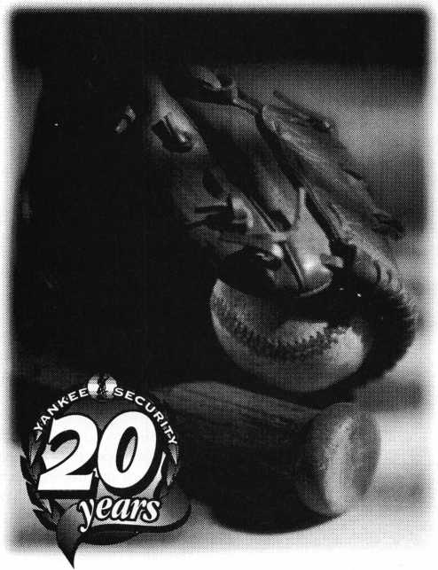

*Famous Happenings*~~F R O *M~*

*1978*

* Baseball legend Reggie Jackson introduces the Reggie Bar
* The first American-made Volkswagen is produced in the  
  United States
* The first test tube baby is born in London
* Chrysler Corporation hires Lee lacocca
* Al Unser captures his fifth Indy 500 title
* ...and a group of New England Locksmiths founded  
  the region's premier security trade show...

The Yankee Security  
Conference

Rhode Island Convention Center, Providence

Oct 21-23 Locksmithing and Security-related Classes

Oct 24-25 Exhibition showcasing Distributors and Manufacturers

For your free show guide, call 1-800-209-8266.

Don't miss the trade show that's hit a home run for 20 years!

Reader Service #2

October 1998

Keynotes

Security

Marketplace

Marks USA

All Marks USA Protector Series mortise locksets feature an “Override Guide” that is designed to result in spindle failure when torque of over 550 foot pounds is applied. Lockset remains locked and when spindle is replaced, it is fully operational.

Marks USA

5300 New Horizons Blvd.

Amityville, NY 11701 (516)225-4400 (516) 225-6136fax Reader Service #9

Marshall Electronics, Inc.

Compact LCD flat panel is compact sized provides a picture in color or monochrome. Display format is 960 x 234 pixels on a 5" diagonal screen. It is used in applications where the monitor must fit into small spaces in industrial equipment. The V-LCD5V also features pixel in stripe configuration, low power consumption and active matrix TFT technology which allows a wide viewing angle and provides a color picture. The V- LCD5V is equipped with VGA, NTSC and RGB switchable inputs to match a variety of industrial applications.

Marshall Electronics, Inc.

PO Box 2027 Culver City, CA 90231 (800) 800-6608 (310) 391-8926fax Reader Service #10

Von Dupvin

Von Duprin has introduced a new keyswitch that is designed for using a delayed egress system, as well as other applications needing keyswitch control with audible and visual feedback. The new KS920 Keyswitch contains a piezo horn rated at 100 dbA mini­mum at two feet, a red LED and both mone­tary and alternate action switches, which are actuated by a mortise cylinder. The unit mounts in a standard two-gang backbox with a 1 3/4" depth. The cylinder and backbox are not included. The KS921 may be used with the Von Duprin PS873 Power Supply equipped with 873-DE Delayed Egress Logic Board to provide delayed egress operation for electromagnetic lock applications.

Von Duprin, Corporation Ingersoll-Rand Company 2720 Tobey Drive Indianapolis, IN 46219 (317)897-9944 (317) 899-9302fax Reader Service #11



Commercial Plastics & Supply Corp,

Commercial Plastics had added Perforated Polymer to their product line. This product is a substitute for perforated metals, aluminum and stainless steel. Perforated Polymer will not rust, dent or crack and it never needs painting, This plas­tic product eliminates snap-off and resists bending and dents. It is easy to clean and can be used in many harsh environments. It can also be cold formed, easily cut and is heat formable, cementable and weldable. It is available in .080 standard thicknesses and sheet size 48 x 96. Other thickness and cus­tom sheet sizes are available upon request. The standard configurations available are .125 diameter holes/.250 staggered and .250 diameter holes/.375 staggered. Other pat­terns are also available.

Commercial Plastics 3448 Progress Drive, Ste. H Bensalem, PA 19020 (800) 452-6036 Reader Service #12

Continental Instruments LLC

Continental Instruments LLC introduced a single door access control system that is self-contained and requires no computer or hand-held programmer. All programming is performed on a built-in keypad which is recognized intuitively through simple commands. CardAccess 25 is compact and offers 1,000 card capacity with expansion capability to 3,000 cards. Other features include the ability to void or validate single cards or groups of cards, choice of magnas- tripe, wiegand or proximity card readers, remote door control, door-open-too-long and forced-door alarms, built-in battery back-up for system operation and ability to search system database for card status without inserting the card into the reader. **Continental Instruments LLC 250-Executive Drive Edgewood, NY 11717 [cic@cicaccess.com](mailto:cic@cicaccess.com) [www.cicacess.com](http://www.cicacess.com) Reader Service #13**

Lockmasters, Inc.

The Bullet is a companion drill rig with the same powerful drill capacity as the standard 457 Magnum. Designed with barrel and quill assembly technology, the Bullet is lightweight quick and easy to set up, and offers template drilling. The template provided with the Bullet includes drill points for the fence, lever screw, relocker and scope for S&G, Ilco and La Gard locks. Other

templates are available for the Mas Hamilton X-07, Mosler and Star Round Doors. An additional blank template is available with the spindle hole and mounting holes predrilled. For side drilling or drilling out­side the dial ring, a guide plate complete with drill brushings is provided to drill the two mounting pattern holes anywhere on the safe.

Lockmaster, Inc.

5085 Danville Rd.

Nicholasville KY 40356-9531 (800) 654-6041 (606) 885-7093 fax Reader Service #14

Adams Rite Manufacturing Co.

Adams Rite Manufacturing Co. has intro­duced two electric strikes with a fire rating. Now the one-ton jaw strength, one million cycle-tested solenoid and choice of popular voltages can be appreciated in applications requiring a three-hour fire rating. The 77240 strike is for key-in-knob latches while the 7270 is for mortise latches. Both strikes are fire-rated in fail-secure mode for hollow steel jambs and are UL listed for burglary resistance. Faceplates for both measure 1 1/4" x 4 7/8". The 7240 strike opening is 5/8" x 1-7/16" x 9/16" and for the 7270, the opening is 3/4" x 1-7/16" x 3/4". The strikes are compatible with latches from virtually all top manufacturers.

Adams Rite

151 N. Kraemer Blvd.

Suite One Hundred Placentia, CA 92870 (714) 993-0893 (714) 993-6337fax Reader Service #15

Securitron Magnalock Corporation

Securitron Magnalock Corporation, an ISO 9001 registered company, introduces a new addition to its family of Power Sources, the PM-12-1 and PM-24-1. Utilizing the same two-time award winning BPS series design, the PM series provides one-amp rated, filtered and regulated, DC battery charging power utilizing a plug-in trans­former. Features include automatic circuit breaker (no glass fuses) for the DC output; fire alarm terminal interface for automatic absence of DC power open fire alarm activa­tion and battery back-up charging circuit for up batteries to 20 amp hour in size. The PM series comes efficiently housed in a 6" x 8" x 2 7/8" metal enclosure.

Securitron Magnalock Corporation (702) 355-5625 (702) 355-5636fax [info@securitron.com](mailto:info@securitron.com) Reader Service #16

***Keynotes***

October 1998

ALOA SCHOLARSHIP FOUNDATION, INC.

ALOA/SAVTA SCHOLARSHIP APPLICATION  
3003 Live Oak Street; Dallas TX 75204; (214) 827-1701

Please print or type

NAMEPRP LEVELALOA/SAVTA#

HOME ADDRESSCITY;STATE ZIP

HOME PHONE -DOBEDUCATIONAL LEVEL (YEARS) DEGREE, IF ANY

PRESENT EMPLOYERWORK PHONEFAX

WORK ADDRESSCITYSTATE ZIP

POSITIONFULL TIME PART TIME TAKE HOME PAY

LENGTH OF TIME IN LOCKSMITHINGOWNER/SUPERVISOR’S FULL NAME MEMBERSHIP IN TRADE ASSOCIATIONS (LIST BY NAME)

MARITAL STATUSSPOUSE’S OCCUPATIONSPOUSE’S TAKE HOME PAY

COMBINED HOUSEHOLD ADJUSTED GROSS INCOMENUMBER OF DEPENDENTS

CLASSES DESIREDDATE OF CLASSES

ORGANIZATION SPONSORING CLASSES: ALOA SAVTA OTHERLOCATION

ALOA Scholarships are granted to selected individuals desirous of entering the locksmithing field or to selected individuals already in the locksmithing field who wish to improve their professional skills through education.

Applications for classes being taken locally must be received a minimum of 60 days prior to the date of the class, and will be reviewed as they are submitted. Scholarships for classes at the ALOA or SAVTA convention will be awarded each year at the ALOA Scholarship Foundation meeting preceding the convention and must be received by March 1 each year.

Please attach to this form a letter stating your reason for applying for a scholarship, what you plan to do with the knowledge you obtain and any other information you feel may be helpful to the scholarship board in making its decision. In addition, attach three letters of reference from individuals who have personal knowledge of your background and character. The letters should contain their names, addresses and phone numbers. It would be helpful if at least one of these references is an ALOA or SAVTA member. Also, please provide a copy of your most recent tax return.

All scholarship recipients will be required to provide a 3 X 5 inch photograph of themselves.

APPLICATION CHECK LIST

Only complete applications will be considered for scholarships. An application is considered incomplete unless ALL of the above requested information is received before the deadline: 60 days prior to the date of a class or March 1 for ALOA/SAVTA convention classes. Please send this application after checking off each of the below.

* I have filled in each blank on this form.
* I have written and enclosed a letter explaining my reason for applying.
* I have enclosed three letters of reference.
* I have enclosed a copy of my most recent tax return.
* I am submitting this in time to be received 60 days prior to the date of a class or by March 1 for ALOA/SAVTA convention classes.

CERTIFICATION OF APPLICANT:

I certify that the information contained herein, and all supplemental forms are complete and correct to the best of my knowledge. I further certify that if i am selected as a scholarship recipient i will use the knowledge gained for the improvement, development and advancement of the locksmithing profession.

SignatureDate 4/98

Trans-Atlantic Co.

Trans-Atlantic Company has announced the availability of several products. Included are Key and Lever Lock Kits. These kits prevent rotation in the locked position. They are sup­plied with two anti-rotation mounting studs and with new deluxe mounting plates with two through bolting sex bolts. It may be used with most brands of rim exit devices. Another set of products is a collection of door knockers with viewer. The knockers are available in polished brass and polished chrome finishes and for use in

1. 3/8" to 1 3/4" thick doors of wood, steel and aluminum construction.

Trans-Atlantic Company

440 Fairmount Ave.

PO Box 37006 Philadelphia, Pa. 19123 Reader Service #17

Sargent and Greenleaf

Sargent and Greenleaf introduced an inte­gration package that links electronic safe locks with an existing centralized security system. When integrated with a current electronic monitoring systems, S&G’s Comptronic Electronic Safe Locks provide increased control over safes, vaults, night depositories, ATMs and other controlled areas. Comptronic Electronic Safe Locks operate independently or can be integrated with a new or existing secu­rity system now or at any time in the future. The line offers a broad range of solutions for everyday locking problems including internal theft, robbery and security mismanagement. **Sargent & Greenleaf, Inc.**

PO Box 930 Nicholasville, KY 40336 Reader Service #18

Thomson Industries, Inc.

Thomson Industries issued a new technical bulletin for FluroNyliner bushing bearing that contains current product specifications, benefits, performance characteristics and a chart rating resistance to common chemicals. A separate section in the bulletin details the closed, open and self-aligning bearings. These bearings are also available in single and twin pillow block versions. When operating in hostile, contami­nated, submerged or washdown conditions, or in a vacuum, the FluoroNyliners bushing bearing requires no additional lubrication. The propri­etary, self-lubricating compositeliner is wear- resistant and able to withstand shock, vibration and temperature extremes up to 550° F.

Thomson Industries, Inc.

1. Channel Drive

Port Washington, NY 11030-2214 (800) 334-8466, (316) 883-9039 Reader Service #19

Mayflower Sales

Mayflower Sales released its first 224-page Security Source catalog. The Security Source Book lists product lines from various brands of access control and electro-mechanical hardware, parts and related products stocked by Mayflower.

Mayflower Sales 614 Bergen Street Brooklyn, NY 11238 (800) 221-2032 (718) 622-8783 fax Reader Service #20

Jensen Tools, Inc.

The Milwaukee 1/2 inch 14.4 Power Plus Cordless Driver/Drill features a motor devel­oping 280 in./lbs. maximum torque. The drill has a pistol-grip handle with a soft-grip pad for comfort as well as dual range and variable speeds of 0 - 450 RPM and 0 - 1250 RPM. Its reversing and has a 19 position clutch. The reversible battery pack creates clearance to fit tight work spaces and adjust balance. Other features include a 1.7 amp battery and a one hour. 115 VAC charger. A driver/drill, two battery packs, a charger and an impact resistant carrying case are included.

Jensen Tools, Inc.

7813 S. 46th Street Phoenix, AZ 83044-3399 (602) 968-6241 (602) 438-1690fax Reader Service #21

CamLock Systems

The following are new items in CamLock s Locksmith product line. They are: the Series 10 Double Entry Cam Lock; Series LL Cam Lock Style Thumb Latch and Series 13 Miniature Tubular Cam Lock. The Series 10 Double Entry Cam Lock offers a “convenience key.” The 8-disc tumbler mechanism provides thousands of key combinations. The lock comes in an alloy die cast body, with a chrome finish. An automotive-style stainless steel dust shutter guards against dirt and moisture. The Series LL Cam Lock-Style Thumb Latch can replace most cam locks where key oper­ation is not required. It comes with a sturdy black chrome die-cast handle. It has a chrome- plated die-cast outer body. Accidental cam rota­tion is prevented by a positive ball bearing detent in both locked and unlocked positions. Series 13 Miniature Tubular Cam Lock is suited for limited space applications. With a four-pin tubular lock mechanism, the lock has a die-cast housing with brass components. It is chrome plated and offers hundreds of key combinations.

For more information, call (888) 972-6373.

Reader Service #22

Security

Marketplace

Ribauldo & Company, Inc.

An intumescent glazing tape developed by Zero International has tested successfully with 1/4-inch wire glass developed for positive pressure fire performance. This INTUMET Glazing System supports a design solution for fire-rated door lites. Similar to typical systems for standard lite kits, it is also designed for convenient application using double-faced tape. The glazing system is listed by ITS/Warnock Hersey for use with 20 minute combustible- core wood doors in lite kits up to the allowable maximum of 1,296 square inches in size, with 1/4-inch wire glass.

Ribauldo & Company, Inc.

343 Millbum Avenue Millbum, New Jersey 07041 (973) 467-7878 (973) 912-8917fax RIBAULDO @ aol.com Reader Service #23

Medeco

Medeco is offering a free information booklet with tips on how to keep homes and businesses safe. The booklet, entitled “Security Tips for Your Home & Business,” gives information on when homes and businesses are most vulnerable to break-in and what can be done to prevent it. It serves as a checklist for personal security and covers everything from suggestions on door security to advice on neighborhood watch programs. **Medeco High Security Locks PO Box 3073 Salem, Va. 24133-0330 (340) 380-3000 (340) 380-3010fax Reader Service #24**

Jet Hardware

Jet Hardware recently unveiled two new key blanks. They consist of the plastic head HU66VW-PH to fit the new Volkswagen Beetle and Passat. The second key on the release is the PZ1 to fit Papaiz. A new cata­log has also been released featuring 100 new keyblanks including transponder and licensed keys plus the new ETD-1 Electronic Transponder Decoder and Duplicator.

Jet Hardware Manufacturing Group 800 Hinsdale St.

Brooklyn, NY 11207 Reader Service #23

October 1998

***Keynotes***

**core**



• Domestic Bliss

Sieveking is offering locksmiths a new and extensive reference book for domestic auto­mobiles. The book, Fast Facts recently took top honors as “Best New Product in Print” at ALOA ’98 in Nashville and may prove to be a convenient index to a wide array of past and present automobiles.

“It’s an encyclopedic index of automobiles manufactured for the North American market from I960 to 1998. It contains listings of up to 2,600 automobiles according to make, model and year,” says Fast Facts author, Bob Sieveking.

Sieveking and wife Jane Sieveking have been locksmiths since 1974. Originally an

index that contains code series, application of the key (master, valet, door, trunk, ignition, etc.), how many cuts are in the key (5,

6,7,11, wafer, etc.) and the type of key to use.

“With one look, the reader will have all the information necessary to identify the key system on a particular vehicle,” he says.

The books is divided into two parts, an index at the front and a section on key plates at the back of the book. And aside from the detailed info., Bob Sieveking adds that one of the best things about Fast Facts is that it’s pocket-sized.

The book retails for $49 and can be purchased at various conventions and

“It’s an encyclopedic index of  
automobiles manufactured for  
the North American market from  
1960 to 1998...This was almost

five years of work..

electrical engineer, Bob’s expertise has allowed him to author other books prior to Fast Facts. He says, however, that compiling the necessary info for the recent award winner was one of the most arduous tasks he’s had to undertake for any text.

“This was almost five years of work,” he says. “It was shelved temporarily because of the amount of research it took to do it. In fact, I’ve written three books in the time since I began Fast Facts.”

Despite the long hours, Sieveking is most pleased with the results and says that during its brief time on market, it’s been well- received by locksmiths.

Included in Fast Facts’ information is an

tradeshows. Among the shows Fast Facts will be available at are: POLA ‘98 in Indepen­dence, Ohio; MINK in Omaha, Neb.; and Yankee Security in Providence, RI. (See “Upcoming Events” on page 8 for more details.)

• Mike Emery

October 1998

1 Keynotes

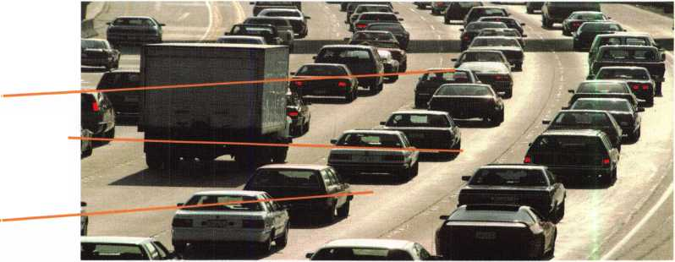

• FRA 2001: A Code Machine Odyssey

Although it was officially introduced at ALOA ‘97, Framon’s FRA-2001 walked away with Best New Product at ALOA ‘98 in Nashville.

The device is a computer driven code machine that connects to a computer (be it a laptop or PC with 3.1 or Windows 95). It is able to combine all the elements of coding. Its equipped with a built-in code program, code database, a depth and space manual (including about 1,000 depth and space charts to reference) and soon customers will have the option of a masterkeying program to purchase alongside the machine.

“Out of one window on your computer screen, you can do just about any kind of

code work imaginable,” says Phil Agius, Framon’s vice president of Sales and Marketing. “It’s an all encompassing software program that brings together all these other programs that are available out there.”

According to Agius the program has been receiving positive feedback from users, prompting Framon to consistently update software every few months. He adds that codes and depth and space charts will be updated on an annual basis.

The list price of $4,900 for the unit and Agius says that the response has exceeded everyone’s expectations.

• Mike Emery

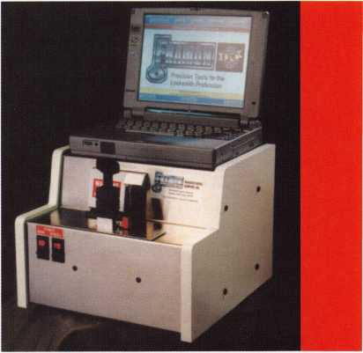

• American Lock Acquired

American Lock has been acquired by its current management and Marathon Fund L.P III, which is managed by the private equity investment firm of Goldner Hawn Johnson & Morrison Incorporated of Minneapolis, MN.

In a recent press release, Phillip Settecase, vice president of Sales and Marketing said that this is an important step in the company’s growth and development.

“The acquisition will make available to us managerial, operational and financial resources that will help us build on our tradition of bringing quality products and services to our customers,” he said. “There will be no interruption in the flow of our business and no unplanned product or personnel changes as a result of the acquisition.”

American Lock’s history dated back to the early 20th century. John Junkunc, a railroad machinist founded the company as Junkunc Safe & Lock Company of McKay, Idaho in 1912. During the ‘20s, Junkunc picked up and headed to Chicago where he acquired a local cylinder manufacturer, American Lock Company. The resulting entity became known as Junkunc Bros. American Lock Company. Until this transaction the company was a privately held family business run by the descendants of John Junkunc.

• Get to Know The Manufacturer

Yes, you can get to know your manufacturer. Security Lock is holding open discussions at their Las Vegas facility. This will allow dealers to communicate on a face-to-face basis with manufacturers of electrical and mechanical security products on topics such as product specification, application and installation. Among other tidbits of information to be made available will be trouble shooting tips, product comparisons and other factors that will be explained.

Recently, Locknetics District Manager, David Middleton provided a lecture and Q&A period. Subjects he tackled included electric circuitry, codes, life safety requirements and new products. Other activities for those in attendance included a hands on-exercise in wiring. Participants were given wiring diagrams and then guided into wiring up a complex multi-product access control system.

For more details contact:

Security Lock Distributors 6320 Sandhill Rd. Unit 3 Las Vegas, NV 89120 (800) 847-5625 (800) 878-6400 fax [seclock@ix.netcom.com](mailto:seclock@ix.netcom.com) <http://www.seclock.com>

October 1998

Keynotes 1

core

•The Defiant Ones

Defiant Safe Company in Dallas, Texas and AANON Safes in Englewood, Colo, (once known as Birmax) recently announced their merger and business consolidation. The resulting enterprise will go under Defiant Safe Company.

In a press release, Rick Rolland, president of Defiant Safe Company said, “This is a win- win situation for all. AANON customers will purchase safes and safe parts from Lorraine Hambleton at the Englewood office just as before. But now, TannVault TL15 and TannDiamond TL30 composite safes manu­factured by John Tann, Ltd. and the Safe Chariot made by Defiant are also available. Conversely, Defiant customers have access to AANON products. This consolidation greatly simplifies product sourcing and ordering processes for customers who before had to shop two different sources.”

* regions

Don’t forget to check the “Upcoming Events” calendar pp. 8-9 for regional associa­tion happenings. ... There are two big conventions going on later this month— MINK in Omaha, Nebraska and Yankee in

Providence, R.I In the next few months,

the Locksmith Security Association of Clinton Township, Mich, will sponsor a series of classes and workshops. A class on Sargent locks will be offered on Oct. 3; On Nov. 7, Labor Saving Devices will be the topic of a class; and Access Control and Card Readers will be discussed on Dec. 5. For more information, call the LSA Times at (810) 791-5416.

* prp

CRLs

Deborah D. Anderson, Live Oak, Fla.

Kathy M. Curry, Loxahatchee, Fla.

Michael Erickson, Downers Grove, 111.

Grant H. Grein, Sr., Fla.

Cliff W. Lafay, Royal Palm Beach, Fla. Michael McAllister, Phoenix, Ariz.

spotlight news



• Canadian Ye/low Pages Advertisers

Here’s something that may be of interest to security professionals who advertise in the Yellow Pages in Alberta, Canada.

TELUS, the advertising company that helps organize the advertising and listings in the Yellow Pages is introducing a new way of sorting entries.

The system will affect those companies with names that begin with a letter or group of letters.

For example “A Cool Lockshop” would appear before “AA Cool Lockshop,” which in turn would appear before “AAA Cool Lockshop.”

The following are the sort rules that apply to Yellow Pages listings:

1. Business and residential listings appear in the directory under the name given by the customer.
2. Listings are inserted alphabetically by surnames and given names or by the name of the company.
3. Letters when used as names are found at the beginning of the listing starting with the first letter, whether they are spaced or not.
4. Characters such as semicolons (;), dashes (-), ampersands (&) and the word, ‘and’ are ignored.
5. Abbreviations sort as if they are spelled out.
6. Numeric characters sort as though they were spelled out.

At press time, we were unaware of any other Yellow Pages that were planning to change their sorting in this way. You might want to check with your sales representative before submitting your next ad.

Keynotes

October 1998

**November 6-8,1998  
Well Be There. Will You?**

ROFU

**WHOLESALE**

**SARGENT®**

*First in quality since 1864*



**Defiant Safe Co.**

***ixTttirrnsEi***

***LOCK DISTRIBUTORS***

**Graffunder**

QjjQ H Safe & Vault Co.

**Marray Enterprises**

RENO - NV. 98

**at the**

**Reno Hilton  
Reno Nevada**

Strong Arm, tree.

**| R.R BOXMAN**

j & ASSOCIATES, INC. ■

**yfefker Hardware**

**Don Carnie Associates**

**Master Lock**

@

CALL KATHY AT (847) 692-5940

AND REGISTER TODAY!

***UJILCO SUPPL Y***

*IJJi yiSe£uritv* medeco®#

**SIERRA PACIFIC**

**VON DUPRIN**

**Part of worldwide Ingersoit-Rand**

**FORT LOCK CORR**

*JIM DANIELS*

***SALES***

SECURITY LOCKS, INC

si

worldwide coverage f-—~

AsfeP B

car locks & lock parts

**'maha Intellikey**

**HOLESALE**

**ARDWARE**

**£T**

*LOCKNETICS*

***l III***

Dor-O-Matic 1 ^security

**1 7 PRODUCTS**

Howard Sales CLARK Company

ccr iiditv 1 J

***TT# LEADER IN THE ACCESS CONTROL TECHNOLOGY***

^instate



MONARCH HARDWARE

ww

OORMA

Yale®

**YALE SECURITY INC.**

**#%zr**

**GLYNN-JOHNSON**

**INGERSOLLHRAND**

ARCHITECTURAL HARDWARE

Security Hardware



**■HAYMANI**

m QUALITY BUILT SAFES I

a.

<0>

>r'

*Chicago*

^simple* (ggjTgj) «T

ACCESS CONTROLS .

— ,—. — I ™



oxara ro)

***Automotive - Alabama***

Access i Iariwarx St*m.Y

**NATIONAL** OCT **CABINET LOCK' I**

*DLR SALES,*

INC.

**Olympus**

**LOCK** inc.

H.E. MITCHELL, COMPANY

HANCHETT ENTRY SYSTEMS, INC I Manufacturing Products for Access Control



**LOW TECH PRODUCTS**

BWD

AMSEC kwikset

**PCSC**

Mfa Norton

**SCHLAGE**

m

**Major**

TJ V LJANUFACTURING. INC.

***SECURITY INNOVATIONS***

PROPftiETARY CONTROLS

systems corporation FALCON HARDWARE

YALE SECURITY INC.

Part of worldwide Ingersoll-Rand

kROkVf%

RjMWHCIME SUfflY, KCT w

i 1.HARDWARE & LOCKSMITH SUPPLIES

*mm*



**MANUFACTURING COMPANY, INC.**

iiiij

**ACCESS HARDWARE SALES. INC.**

Reader Service #3

**NATIONAL CUARD  
PRODUCTS**

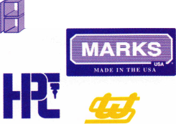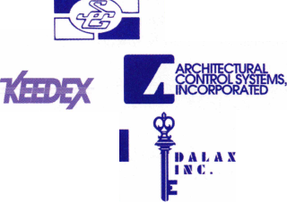

**Hffl**

**lock**

**Tools**

from

Sieveking

Products

by Sal Dulcamaro, CML

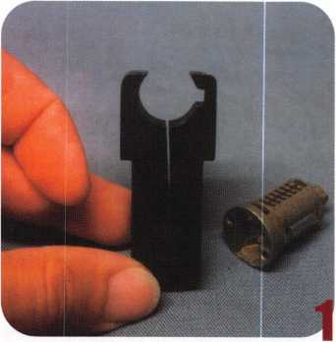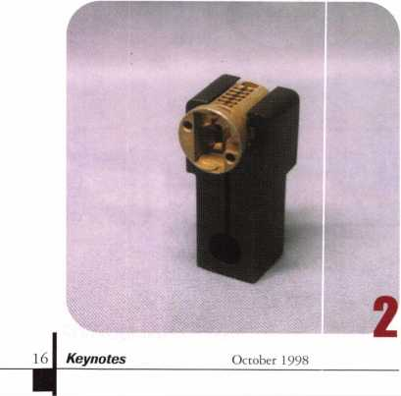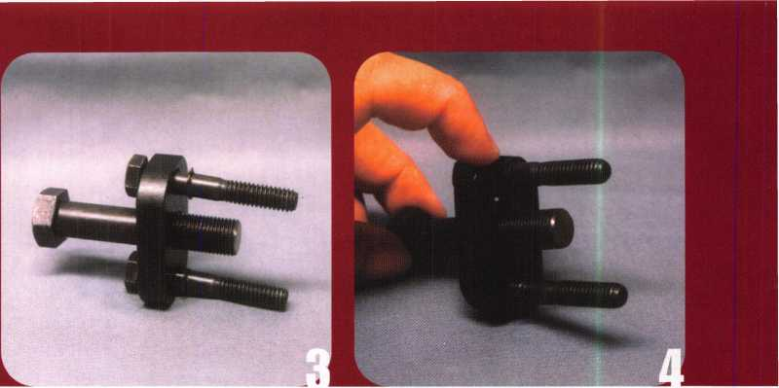

There are a number of interesting locksmith tools made by Sieveking Products Company. A good number of them can be particularly useful for the automotive locksmith. The owner of the company, Bob Sieveking, is well known in the industry as the author of many technical articles and very informative technical books for the locksmith. The many tools he has designed, reflect his long experience and knowledge as a locksmith.

Photo 1 shows the small format Clamp-King. It is essentially a specialized holding fixture.

This tool can be quite handy if you need to service GM sidebar lock cylinder plugs. Just to the right of the tool is a GM door lock cylinder plug. There are tumblers in the plug that cause the sidebar to extend outward to the right. Tumbler springs have not been assembled. The opening of the Clamp-King can accommodate not only the outside diameter of the cylinder plug, but the extended sidebar too.

The tool is especially effective if you wish to remove or replace a spring retainer/cover. In some GM plug holding fixtures, there is no place for the sidebar to go. If you had a fixture like that, you would have to pick the lock first in order to pull in the sidebar. When picked, the tumblers sit higher in their slots and require additional compression of the tumbler springs in order to seat the spring retainer.

Photo 2 shows how the plug fits into the Clamp-King. This tool is designed to be held in the jaws of a bench vise, where tightening of the jaws applies even pressure around the circumference of the plug. In that way, there is no marring or damage of the plug. At the same time, the plug is held very firmly and securely. The sidebar can remain extended without any interference from the tool, because of the built-in sidebar slot.

Once the tumbler springs are loaded, the spring retainer can be positioned without having to worry about overly compressed springs trying to push the cover back off. Seating and staking the spring retainer becomes a much easier task. You have much lower chance of damaging springs when the tumblers are at the bottom of their chambers, and pressure is off the springs.

The Clamp-King is also effective as a holding fixture when trying to remove a staked-on spring retainer. I tend to use a new GM plug rather than re-use an old one. There are times, however, when a customer has a GM lock that uses a somewhat unusual plug, and I don’t have a replacement readily available. Before giving up on the lock, I will usually try to salvage the old plug. Without having a secure and solid fixture, there is a greater chance of breaking the spring retainer when trying to remove it. This tool will dramatically improve your chance at success.

The Clamp-King can also be used for decoding, by loading the plug into the fixture from the opposite side. After picking the plug, you can load it (while holding the sidebar inward) into the tool from the opposite side so that the sidebar slot is not in line with the sidebar. The inside surface of the tool will hold the sidebar in the unlocked position while you use a decoder tool to • decode the tumbler sizes.

Although not automotive related, this tool can also be used as a holding fixture for a number of knob (and lever handle) lock cylinders. It generally works with those with lock cylinder shells that have somewhat thinner walls. It works with Schlage and Arrow, and a few other knob cylinders, and it is very useful for aftermarket high security cylinders (that go into Schlage, Arrow and other locksets) like ASSA and Medeco that normally need to be staked for lock cylinder assembly. The Clamp-King evenly distributes the force used when staking the slide covers, without damaging the lock cylinder.

Photo 3 shows the E-Z Pull. It is a GM steering wheel puller designed for professional locksmiths. It should work with all GM steering wheels, standard and tilt (and tilt/telescopic).

It should also work for most Chrysler tilt wheels that use the Saginaw column. It is solidly built, with a hardened chrome molly steel puller beam and grade “5” hardened bolts. It is black oxide coated to resist rusting. The E-Z Pull uses bolts of a pilotless design to avoid damaging or deforming the steering shaft. In photo 4,1 am pointing to a snap ring on the shaft of one of the bolts. The snap rings on the two bolts keep them from being separated from the tool. The captive-bolt design is intended to minimize search time in your tool case trying to find the separate parts to your puller.

In photo 5, you can see two versions of a tool called the “No-Pick GM Glove Box Tool.” They are designed to remove most GM glove box plugs that use a retainer tumbler to secure the plug inside the lock body. With very little practice, you can remove GM glove box lock plugs without having to pick the lock first. It can also be done with the glove box locked and shut, inside the car.

The close-up details in photo 6 hint at how the tools work. The very small slots on the end of the tools fit over the raised spots in the middle portions of the retainer tumblers. Notice that there are two types of tools to accommodate two different versions of the retainer tumblers. Retainer tumblers are matched by general keyway shape. The tool on the left is for the GM secondary keyways “B” and “D” (and for some Chrysler glove box locks). The retainer tumbler on the left would require that tool. The tool on the right is for GM secondary keyways “H” and “K,” which matches the retainer tumbler on the right side. You must use the correct tool to match its corresponding keyways.

Photo 7 shows how the tool interacts with a retainer tumbler. The small slot in the end of the tool operates within the middle of the retainer tumbler and grabs onto the raised spot on the inside left surface of the tumbler. With the tool gripped onto the retainer tumbler, it

can be pulled downward in the keyway until the retainer is fully contained in the plug. Then the plug can be pulled outward. There is no bottom surface on these retainer tumblers (as with some other disc tumbler locks that use retainer tumblers), so you can’t just use a standard pick or probe on the bottom surface of the tumbler to pull inward to deactivate it.

The process begins in photo 8. The correct tool must be matched to the keyway. With the tool properly oriented, it is ready to insert into the keyway. It takes a little bit of practice to get comfortable using this tool, but it is rather easy to do it. The tool is in the keyway in photo 9- At this point, feel for the correct spot and make sure that the tool is deep enough into the keyway (but not too deep) to engage the retainer tumbler. GM glove box locks always have the retainer tumbler toward the front face of the plug. When you think you have a secure grip on the retainer tumbler, pull downward. The retainer tumbler has been fully retracted into the plug in photo 10.

It will be easier to practice (and see what you’re doing) if you work on the plug when it is outside the glove box lock body. You’ll normally use the tool when the plug is still attached, but you won’t have as good a view of what’s happening inside the plug. After a little practice, you’ll be able to do it rather quickly. When the retainer tumbler is deactivated, the plug will only come

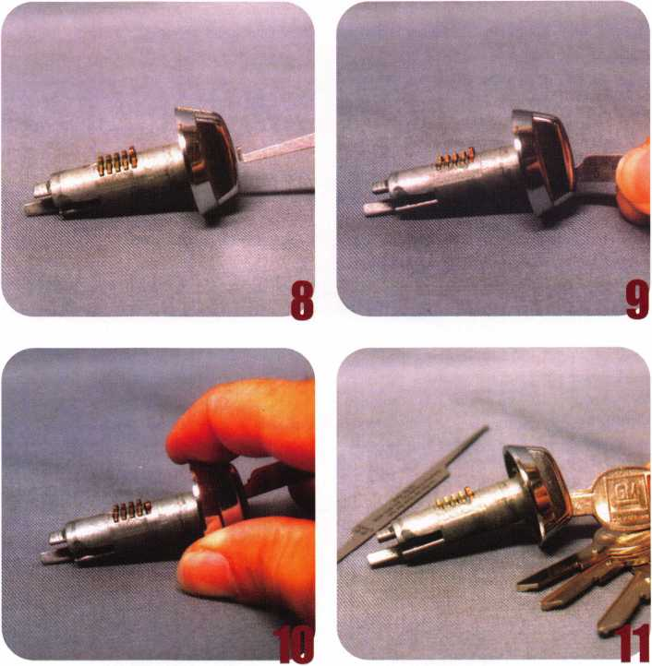

October 1998

Keynotes

out a short distance. The normal operating tumblers will also act like retainer tumblers, but they have a bottom surface and can be pulled into the plug with an ordinary pick.

The opposite end of the “No-Pick” tool is a half diamond shape pick, and it can be used to pull down the operating tumblers (one at a time) until the glove box plug comes completely out of the lock.

You will need to know the GM secondary keyway with which you are dealing in order to select the proper “No-Pick” tool. If you use the wrong tool, you will end up wasting a lot of time and get absolutely nowhere. Photo 11 shows a ring of four keys. These are the four standard GM secondary keyways: “B,” “D,” “H” and “K.” It might be worth your while to keep a set of blank keys like this one with your “No-Pick” tool set. Just try each one until you can identify the keyway, and then choose the appropriate tool.

The Universal Wafer Lock Reader is shown in photo 12. This tool is not limited to auto locks, but is designed to work with most disc (wafer) tumbler locks. Since the vast majority of automobiles currently made use disc tumbler locks, this might be useful for the automotive locksmith. This tool is a visual aid to sight reading disc tumblers.

If you are fairly familiar with disc tumbler locks, you probably know that it is possible to visually identify the tumbler “size” by how far the key contacting surface of the tumbler descends into the keyway. Like other skills, sight reading takes practice to become proficient. I will not go into great detail about the process, but Bob Sieveking has authored a book on the subject. If you are unfamiliar with how sight reading works, you may want to check out that book. At this point, I will presume that you have some knowledge about

the subject.

The Universal Wafer Lock Reader acts as a combination tumbler probe and reference scale. It allows you to manipulate the tumblers in order to observe their relative positions within the keyway, and with the scale judge the approx­imate height. Photo 13 shows the tool inserted into the keyway. It is used to lift tumblers in front, to get a view of tumblers further into the keyway. Photo 14 shows a more detailed view of the scale (with increment marks) at the reading tip of the tool.

The increments on the scale are only for general reference. Actual number and depth of increments used for various brand disc tumbler locks vary widely. The scale is very useful in that it gives you a fixed point of reference within the keyway, and minimizes the need for you to use your imagination and guesstimate the positioning of tumblers within the keyway.

Although some practioners of the art are extremely precise when they sight read a disc tumbler lock, you don’t have to be absolutely expert in order to benefit from it. The combina­tion of “approximate” sight reading and lock impressioning will allow you to impression keys faster with a minimum of actual wear to the lock you are impressioning. Although many locksmiths don’t always consider it, impres­sioning can sometimes cause significant wear on a lock; especially a disc tumbler lock. Assisting the impressioning process with sight reading can help minimize that amount of wear.

Photo 15 shows an item that some locksmiths might not consider a tool. It is my contention that information is often your most valuable tool. This is a pocket sized reference book published by Bob Sieveking. Fast Facts is a compact reference book on auto locks. This book can help when deciding whether you can handle a particular auto job, and if so, what kind of work might be involved so you can price it properly and still make a profit. [Editor’s note: You can learn more about Fast Facts on page 12 of this issue in “Core.”] There are other tools and products available from Sieveking Products Company designed for the locksmith, but not necessarily for automotive locksmithing. You can get more information about the items mentioned above and others by contacting: Sieveking Products Company; P.O. Box 4287; Rockford, IL 61110; (815)874-4030.

Keynotes

October 1998

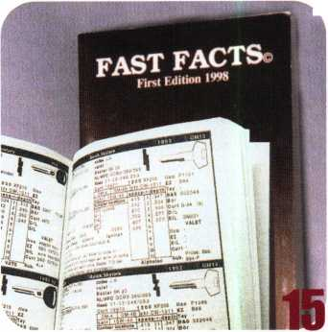

**Working hard for Members’ interests during the first legislative session by Tim McMullen**

Looking back through the last nine months of Legislative Comments in Keynotes, I realize just how much was accomplished since January. So here’s the latest on what’s been going on:

INDUSTRY POSITION PAPER

In the February edition of Keynotes, I reported on an Industry Position Paper that is currently supported by more than 120 manu­facturers and distributors. Since that report, we’ve received important endorsements from other industry associations as well.

The National Burglar and Fire Alarm Association (NBFAA) endorsed the position paper at their summer board meeting, and the Security Industry Association (SIA) recently approved the paper at their ISC show in New York. These two association endorsements are important to ALOA because of the members they represent.

THE LOW VOLTAGE SYSTEMS ALLIANCE

ALOA is taking the lead once again. In the March and May issue of Keynotes, I reported on the first meeting of Electronic and Physical Security Industry Coalition (EPSIC). If you recall, this group was represented by all of the major organizations in the security industry, and met to discuss legislative issues. The group has since been renamed the Low-Voltage Systems Alliance (LVSA), and is being chaired by ALOA. The mission of the LVSA is “to share and coordinate governmental relations issues of mutual interest for the purpose of creating and maintaining a regulatory environment that is conducive to the growth of the low-voltage systems industries.” The main idea is to exchange lists of legislation each group is tracking, and respond to objectionable legislation accordingly. For instance, in Massachusetts, the state legislature is considering a funding bill for installing the internet in public schools. That sounds pretty great, right? Well, if you were to look further, you would see that only electrical contractors are allowed to do the work! What happens when the next bill comes along funding security for adult care centers, that only allows electrical contractors to put in access control systems? These are the emerging issues ALOA is monitoring for its members.

NBFAA MODEL LAW

Working hard to ensure locksmiths who work in access control are not brought into unnecessary alarm licensing qualifications, ALOA is close to getting definitions changed to the Model Law NBFAA is promoting. Originally, the law had one category for “electronic security.” ALOA pressed NBFAA to separate out that category into “electronic access control” and “security alarms.” With an agreement on terms, this should eliminate the problems we have had in the past with NBFAA’s licensing legislation.

PRE-FILING OF BILLS

Usually, the summer is a slow time for state and federal govern­ments, especially during an election year. Most people think that nothing happens until after the holidays, but once the leaves start turning in early October, legislation starts to make its way into legislator’s hands. The “pre-filing” of bills is common in most state legislatures. October and November are usually the heaviest months when it comes to pre-filing new legislation. In fact, it was because Maryland’s Senate Bill 61 was pre-filed that ALOA was able to respond so quickly.

Through ALOA’s Statetrack service (see September Keynotes), we are able to identify most of the bills that are filed before a regular session begins, but you also play a vital role. By checking with the Clerk or Secretary of your state’s Senate or House, you can know precisely when a bill has been filed. Then, let ALOA know so we can get the message out to the other members in your state.

On a final note, the Legislative department for ALOA was recently re-named the Government Affairs department. This name better reflects the broader scope of what we do for our members.

LEGISLATIVE UPDATE

CALIFORNIA AB 1987 Relates to existing law regarding the licensure and regulation of community care facilities or residential care facilities; prohibits security window bars from being installed or maintained on any of these facilities, on and after Jan. 1, 1999, unless the security window bars meet current state and local requirements, as applicable, for security window bars and safety release devices. SIGNED by Governor.

CALIFORNIA SB 1361 Authorizes any adult day health care centers that provide care and supervision for adults with Alzheimer’s disease and other dementia to install designated security devices, such as security bars, for the safety and security of those individuals if the facilities meet prescribed requirements. ENROLLED.

CALIFORNIA SB 1405 Prohibits the sale of security bars, unless the bars are either labeled or their packaging contains warning infor­mation operative on July 1, 1998, and requires the State Fire Marshall to distribute public education materials about the dangers of illegal burglar bars, to the extent that resources are available; requires the State Fire Marshall to adopt on or before Sept. 1, 1999, regulations to control the quality and installation of the security bars. ENROLLED.

October 1998

Keynotes I



A

utotel is an interesting new computer program that is well  
suited for the professional locksmith who does automotive  
locksmithing. It is a vehicle database that covers most  
import and domestic automobiles. There is a little bit of

information for motorcycle locks, but that will probably be more  
complete in future revisions of Autotel.

The software is currently available in two versions: ATWIN31  
350 (for Windows 3.1) and ATSIN95 350 (for Windows ’95 or ’98).

There isn’t a Macintosh version, but  
most of the newer Macintosh  
(power PC) computers can be made  
to run Windows based software.

The system minimum require-  
ments are: 486 33 mz, 16 meg  
RAM, Windows 3.1 or Windows  
’95 (or ’98), 14 meg hard disk space  
and mouse.

Autotel is distributed by H. E.

Mitchell Co. and other locksmith  
supply distributors in the P.L.S.

Group that include: E. L.

Reinhardt, Locks Company, Maziuk  
& Co., McDonald DASH and R&H  
Wholesale. H. E. Mitchell is the  
same company that distributes the  
EEZ Reader auto lock decoding  
tools, probably the most effective  
(and easy) tools an automotive  
locksmith could use. Your auto lock  
tools set is not complete without at  
least a few EEZ Readers.

Autotel is essentially a database  
containing pertinent information  
related to automotive locks and  
keys. I was impressed with both the  
layout of the program and the  
content of the database. It covers  
virtually all import and domestic  
auto companies, and it includes car  
models dating back to the early  
1970s (and earlier). You can search  
for particular cars by alphabetic  
listings organized by either make or

model names. You can also just type

in a car name and go directly to the particular car  
for which you are looking. When the program calls  
up the name of the car which you seek, it will list  
all the years that it was manufactured.

Many different automobiles use the same  
key and lock combinations for numerous  
years in succession. At the same time, many  
other cars change or redesign their locks and  
keys on a fairly regular basis. After you select the  
car model name, you must select the correct  
model year for the vehicle. For some cars, there  
are mid-year model changes. Autotel indicates, in  
a number of different car model categories, two

different sets of parts and key information that could apply to  
a particular automobile.

First you must use the mouse to choose the make, model and year  
of the car for which you need information. Once it has been selected,  
you can choose various requests covering specific information. Your  
selections could include ignition, door locks, trunk/deck and glove  
box or other compartment locks. In most of these categories, you  
will often find part numbers for original and aftermarket keys and

locks. Locks service kits are  
listed, as are various parts and  
the key blank information.

Right clicking a number of  
different fields displayed on your  
computer monitor’s screen, will  
provide you with additional  
useful information. Right  
clicking the mouse, when on the  
key blank number, will compare  
the key blank number to those  
of other brand after-market key  
blank manufacturers. In most  
cases, space and depth informa-  
tion (plus Continental Micro, or  
HPC code card numbers) will  
accompany the other items.  
There are arrow icons (buttons),  
at the top of the screen, that  
will allow you to go forward or  
backward in time for a  
particular car model that you  
are checking. If you wish to  
switch to information for a  
different car model, you will  
need to click on the “Clear”  
button. Only when checking on  
a car for a different year (but  
exact same make and model)  
can you use the arrow keys to  
choose other car models without  
clearing the system first.

While there are specific  
categories of information for  
each record (or car make, model  
and year), not every one will have

information in each category. For instance, some

locks can be purchased coded or uncoded.

Sometimes there will be an OEM lock and after-  
market lock listed. Certain locks can be  
ordered in sets from some lock manufacturers,  
and others are not. Parts breakdown could  
include tumblers, springs, caps and more.

Each lock, key or part also has a price available  
by right clicking the mouse. You can find the  
retail price, or you can select your price (I  
presume the wholesale price offered by P.L.S.  
Group distributors).

There are special notes in various places that

**Autotel Tells All**

by Sal Dulcamara, CML

Keynotes

October 1998



can be accessed by right clicking the mouse. You can also make your own notes throughout the various car lock categories.

In the next version of Autotel, there will be graphic illustrations of the various locks and parts. That means you can see what the item looks like, as if the program was an illus­trated catalog. Another very useful feature is the ability to make a work estimate. If you’ll be doing a variety of auto lock work, you can put each of the retail items on your work list plus the cost of labor. There is a not entirely complete flat rate guide built into the program. You can choose your hourly rate and use the programs time allotment, or increase or decrease the time needed based on your own experience. You would be able to provide your customer with a fairly accurate price estimate before you started the job.

This program seems almost ideal for the automotive locksmith. When a customer calls and asks for service for a particular automobile, you can select the specific car by make, model and year. Once you see what keys, locks or parts are needed, you could check to see if you had the items in stock or if you needed to order them first. It gives you most of the information you will need, to determine whether you can take on a particular job.

I’d like to mention one particularly useful feature. Autotel gives you a substitute key list (if any keys can be substituted), to use as alternatives if you don’t have the recom­mended proper key for a particular model car. Years ago, when the huge glut of different import automobiles began, I would find out what new automotive key blanks were being introduced and promptly buy 10 of each. After a while, my import auto key board was growing so fast that I decided to wait for a specific demand for a key before stocking it. I did that because the majority of the new auto keys I was buying just gathered dust, while certain ones sold out regularly.

I know that many import auto keys are interchangeable because they are often made for the same company but under a different name plate. I just didn’t have a quick reference to tell whether the job I turned down (because I didn’t have the correct blank) was possible by using a key blank that I had in stock (but identified as for a different automobile). I like this feature of Autotel, and I think most locksmiths will also appreciate its value.

I can say that I was genuinely impressed with Autotel, although it is still a work in progress. I say that because I have been told that a lot more information will be included in future versions of this program.

I’m looking forward to seeing those improvements. If you would like more information about Autotel, you can contact: H. E. Mitchell in Portland, Oregon, 800/626-5625. Other P.L.S. distributors are: E. L. Reinhardt, St. Paul, Minnesota,

800/328-1311; Locks Company, Miami, Florida, 800/288-0801; Maziuk & Co., Syracuse, New York, 800/777-5945; McDonald DASH, Memphis, Tennessee, 800/238-7541; and R&H Wholesale, San Francisco, California, 800/367-5625.

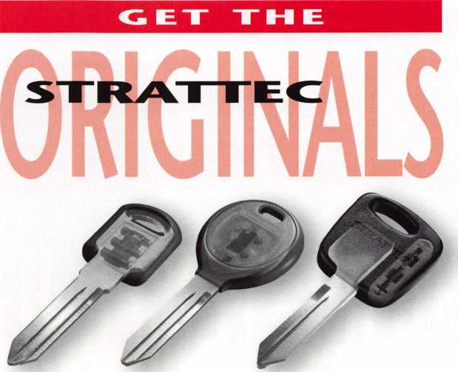

OEIVI KEYBLANKS.

When it comes to automotive locks and keys, look no further than STRATTEC: the original original. STRATTEC is the innovation leader in vehicle security, and we've been at it since 1914. STRATTEC continues to hold a big lead as the OEM supplier for almost all North American production. 62% of Ford, 92% of CM, and a whopping 100% of Chrysler vehicles come off the line and hit the road with genuine STRATTEC parts. For security, reliabilty, and unmatched service and support, you can't beat STRATTEC parts. The original originals.



**STRATTEC**

For more information, please call  
your STRATTEC authorized wholesale lock distributor

Reader Service #4

October 1998

Keynotes



High-tech automotive security is moving fast these days—and the new technology is here to stay. More than HALF of all vehicles to be built in the model year 2000 plan to use what has been called the ‘next generation in automotive security/

So what does this technological revolution mean for today’s locksmith? It spells new opportunity. STRATTEC has helped usher in this age of high tech automotive security back in 1986. It began with the introduction of General Motors’ VATS—Vehicle Anti- Theft System, now known as PASSKey II—developed initially for Corvettes. The technology spread steadily to other GM models. The pioneering device quickly proved its worth, reducing Corvette thefts by 45 percent.

22 | KeynotesOctober 1998

BIG THREE PUSHES TREND

VATS combines mechanical and electronic components. The result: The vehicle will start only when its onboard computer recognizes the correct resistance provided by the ignition key. By the early 1990s, VATS was widely used in GM cars. Today, it’s standard equipment on two dozen GM models and can be found in more than 10 million GM vehicles on the road.

In 1996, Ford introduced its PATS (Passive Anti-Theft System) in domestic vehicles, using radio frequency identification (RFID) system. That same year, GM began a PASSLock electromagnetic system—also known as MRD—which features a small magnet in a sidebar cylinder and Hall-effect sensor on the sleeve assembly.

In 1997, GM brought out its PASSKey III (RFID) system on selected vehicles, using a transponder inside the head of the key. (Transponder, as you know, means Transmitter plus Responder.)

Chrysler followed in 1998 with its own radio frequency identification system, SKIM (Sentry Key Immobilizer Module), available on selected models. In the radio frequency technology of the transponder, an antenna mounted in the steering column receives the one-in-a-trillion electronic code of the ignition key’s transponder and, if the computer recognizes the code as valid, allows the car to start.

All of these sophisticated systems address the THREE most common types of car theft: hot wiring (electronically bypassing the

ignition lock to start the car manually); pulling the lock (pulling the plug out of the lock, usually with a dent-puller, and turning the ignition with a screwdriver); and forced rotation (placing enough force on the lock to break the locking mechanism and start the car).

CAR DEALER SERVICING ISN'T REQUIRED

The concept of high tech security ignition systems took place in Europe, and spread rapidly to the United States. It still leaves some locksmiths apprehensive, wondering if it might leave them in the cold. The answer: Definitely not. These theft-deterrent systems do not lock out the locksmith.

The truth is, the lock systems of most cars do NOT have to be serviced by car dealers. So, for service technicians, todays decision is simple: Embrace this evolving technology and you should be able to capitalize on the new opportunity it presents. It can bring a healthy increase in profits.

KNOWLEDGE IS THE KEY

Now that technology is replacing the old mechanical locks, how can you best meet today’s high tech challenge?

The key is knowledge. The more you learn about this advanced technology, the healthier your business’ bottom line will be. STRATTEC offers training courses throughout the United States and Canada.

To find out more, talk to your STRATTEC distributor or to the Associated Locksmiths of America. And always remember this guideline: Read the application chart closely and pay attention to the parts numbers, and the system is very workable.

So, as we accelerate toward 1999, what are some tips you might find useful?

FDRD: In many ’96 and ’97 models, you could reprogram your security system with just ONE transponder key. Now, in ’98 and ’99, you must have TWO keys to add keys to the vehicle’s memory. (There are exceptions. The two-key reprogramming affects some late ’97 Explorers. And some ’98 Expeditions can be reprogrammed with one key.)

GENERAL MOTORS: From ’97 through ’99 models, GM cars using the PASSKey III (RFID) system are still reprogrammable with just one key.

**FDRD KEYS**

How do you generate Ford PATS keys for 1996 and 1997 vehicles, and some ‘98 Expeditions, as well as some ’97 Explorers? A point to remember: these vehicles are equipped with a 16-key memory. These are the steps to be followed:

1. Generate a working mechanical key.
2. Cut bitting onto PATS key blank.
3. Turn ignition On. Security light on instrument panel will flash.
4. When the security light goes out, turn ignition Off. (This takes about 15 minutes.}
5. Within five minutes, turn ignition On again.
6. Repeat steps 3 through 5 two more times. The vehicle is programmed.

PATS key generation is slightly different for 1998 and 1999 vehicles. This includes some ’98 Expeditions and some ’97 Explorers. You must have two preprogrammed PATS keys. If you do not, Ford electronic diagnostic equipment is required. Here are the steps to add keys when two pre-programmed keys are available:

1. Cut the correct mechanical code onto a PATS key blank.
2. Insert the first programmed key into the ignition and turn from Off to Run [On}.
3. Leave in the Run position for one second.
4. Turn ignition to the Off position, and remove the first key.
5. Within five seconds, insert the second programmed key into the ignition and turn from Off to Run. Leave in the Run position for one second.
6. Turn ignition to the Off position, and remove the second key.
7. Within 10 seconds, insert the unprogrammed key into the ignition, and turn from Off to Run. Leave in the Run position for one second. The key is now programmed. Repeat the process for additional keys.

**GENERAL MDTDRS KEYS**

How do you reprogram a GM car for its PASSLock system (the electromagnetic ignition lock}?

1. Replace the ignition lock. (There are no wires connected to the cylinder of PASSLock, so cylinder replacement is the same as with other modular-style locks. A three-wire lead connects the sensor on the housing to the onboard computer at the base of the steering column.}
2. Try to start the vehicle with a correctly cut key. There is a one-in-10 chance the car will start.
3. If the new lock does not match the electronic value in the vehicle’s computer, an instrument panel indicator light will begin flashing and the car will

be disabled.

1. Leave the ignition in the Run (On} position.

After approximately 10 minutes, the light will stop  
flashing and remain on. The onboard computer  
has been programmed to accept the

new lock’s signal.} The vehicle  
can be started.

October 1998

***Keynotes***

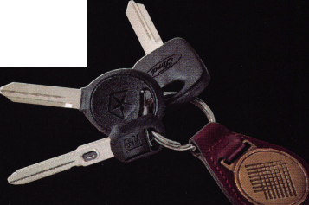

GM KEYS

How do you reprogram the 1999 PASSKey III keys for selected GM models when no pre-programmed working key is available? This reprogramming will erase the memory of any/all previously programmed keys. The assumption is that the old keys have been lost or stolen, so they should be removed from memory. [Note: The GM system’s computer can accept a maximum of 10 authorized keys.] Here’s the eight-step process:

1. Insert an unprogrammed, properly cut PASSKey III key blank into the ignition.
2. Turn from the Off to the On position. The security light will illuminate for approximately 10 minutes.
3. When the security light goes out, immediately turn from On to Off, and remove the key.
4. Within five seconds, insert the same key, and turn from Off to On. The security light will illuminate for approximately 10 minutes.
5. When the security light goes out, immediately turn from On to Off, and remove the key.
6. Within five seconds, insert the same key, and turn from Off to On.

The security light will illuminate for approximately 10 minutes.

1. When the security light goes out, immediately turn from On to Off, and remove the key.
2. Insert the same key for the fourth time and turn to the On position. At this time, the security light will remain off, indicating successful reprogramming of the system.

How do you program additional PASSKey III keys? Here’s the three-step procedure to be used to introduce additional keys to a vehicle when a pre-programmed key is available.

1. Insert any pre-programmed PASSKey III key blank into the ignition and turn from the Off to the On position. The security light will illuminate.
2. After the security light goes off, turn from the On to the Off position and remove the pre-programmed key blank.
3. Within five seconds, insert the unprogrammed, properly cut PASSKey III key blank into the ignition, and turn from Off to On. The security light will extinguish when the new key blank is programmed.

CHRYSLER KEYS

How do you create spare Smart keys for selected Chrysler vehicles?

You must have two already programmed Smart keys. If you do not have two correctly programmed keys, use the DART. tool. And remember, the vehicle can only accept up to eight Smart keys. Here are the seven steps:

1. Cut the mechanical onto the Smart key blank.
2. Insert one of the two preprogrammed Smart keys into the ignition lock and turn to the On position.
3. Leave the ignition in the On position for five to 15 seconds, then turn to the Off position.
4. Within 15 seconds, insert the second preprogrammed key and turn to On position. In 10 seconds, the security light will flash, and a single chime will sound to indicate that the system is in the programming mode.
5. Within 60 seconds, remove the second key.
6. Insert the new key and turn to On position. After 10 seconds, a single chime will sound and the security light will stop.
7. Wait five seconds, then turn to Off position. The vehicle is programmed.

To service GM’s PASSKey II (VATS) systems, the STRATTEC Interrogator lines— the Next Generation Deluxe Kit, #704520, or the Next Generation tool #704500—make the job quick and easy.

CHRYSLER : Its transponder involves not only programming the system to recognize keys, but actually programming information into the keys themselves. A key programmed for one vehicle cannot be programmed to work in another due to the vehicle’s PIN number being retained in the transponder’s memory. Also, if there are no working keys available, a new operating key cannot be programmed if the car’s own PIN number is not known. (Programming the system to accept a new key involves inputting a PIN. The transponder retains in its memory the vehicle’s PIN number.) Programming and troubleshooting can be accomplished with STRATTEC’s electronic tool called D.A.R.T. (#704630), which allows programming of the vehicle to accept up to eight keys.

Finally, a key point to remember in working on any vehicle lock. Whenever possible, use original parts. There are many subtleties and built-in sophistications in today’s technology. For the reliability you need, your best bet is to stick with the source that designed and engineered the locks and keys. Trust the original.

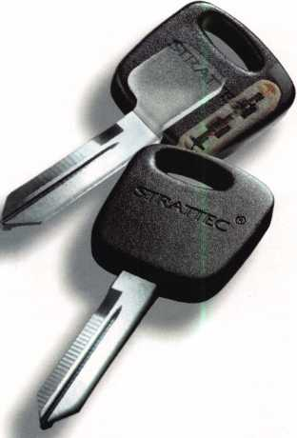

shallower false notch, designed to increase pick resistance. There are five tumbler sizes of all three styles of tumbler.

BWD is also introducing the new LC6940 and LC6949U Chrysler 8-Cut ignition locks. The “U” indicates “uncoded.” This lock group covers a majority of the 1998 and 1999 Chrysler vehicles. They can be serviced with the SK6949 Chrysler 8-Cut Service Kit. The vehicles that can use the new BWD ignition locks for 1998+ are the following:

Chrysler: Cirrus, Concorde, New Yorker,

Sebring Convertible, Town & Country Van.

Dodge: Caravan, Intrepid, Neon, Stratus,

Vision. Jeep: Cherokee, Wrangler Plymouth: Breeze, Neon, Voyager.

A sample of one of the new ignition locks is shown in photo 4. It uses the 8-cut key, and the lock has eight sidebar tumblers. The plug has been removed in photo 5. The sidebar is exposed to view. The lock has eight double throw disc style tumblers with a notch on the side to allow entry of the sidebar to unlock the lock. The key is double sided and must be cut on both sides to operate the tumblers coming from both the up and down directions within the lock plug.

BWD is introducing many other new products including specialized auto lock service guides. Instead of being in an ency­clopedia format, with every car lock included, you can order a pamphlet with the information on a particular auto that you might need. BWD products should be available from the same suppliers that you may have bought All Lock brand products in the past. For additional information, contact BWD at: 900 Ravenwood Drive, Selma, AL; (334) 874-9001, (334) 874-9011, fax.

October 1998 Keynotes

It seems that lock brand names that many of us are familiar with seem to change more frequently in recent years. All Lock, a company that many of us have known for years as a maker of automotive locks, keys, and service kits, is now known as BWD, which is now part of a much larger automotive coporation that will give it more financial resources. BWD Automotive- Alabama appears to be going into the auto lock market more aggressively.

One of the newer automotive lock products that they are offering is a Chrysler 8-Cut Service Kit to service the new 8 tumbler sidebar ignition locks. Shown in photo 1, its part number is SK6949. The service kit can also be used for servicing the door, trunk and glove box locks that use tumblers and parts compatible with those used on earlier Chrysler vehicles that used the 7-cut key.

Photo 2 shows the inside of the service kit. The lid illustrates the layout of the kit. Glove box tumblers are in the first row. Door and deck (trunk) lock tumblers are in the fourth row, and sidebar ignition locks use tumblers in the bottom row. This kit also includes black and silver face plates for door and deck locks, tumbler springs, lock return springs, shutters and other lock related parts. The part numbers are indicated on the lid, to allow you to order replacement parts when individual compartments of the kit run low.

A comparison of the three different style tumblers is shown in photo 3. All three are number one (#1) size tumblers. At the left: is a glove box tumbler. In the middle is a door/deck lock tumbler, and at the right is a sidebar lock tumbler. The sidebar tumbler has a deeper notch toward its middle on its left side. Just below that notch is a much

**Chrysler**

**8-Cut; Service Kit**

by Sal Dulcamaro, CML

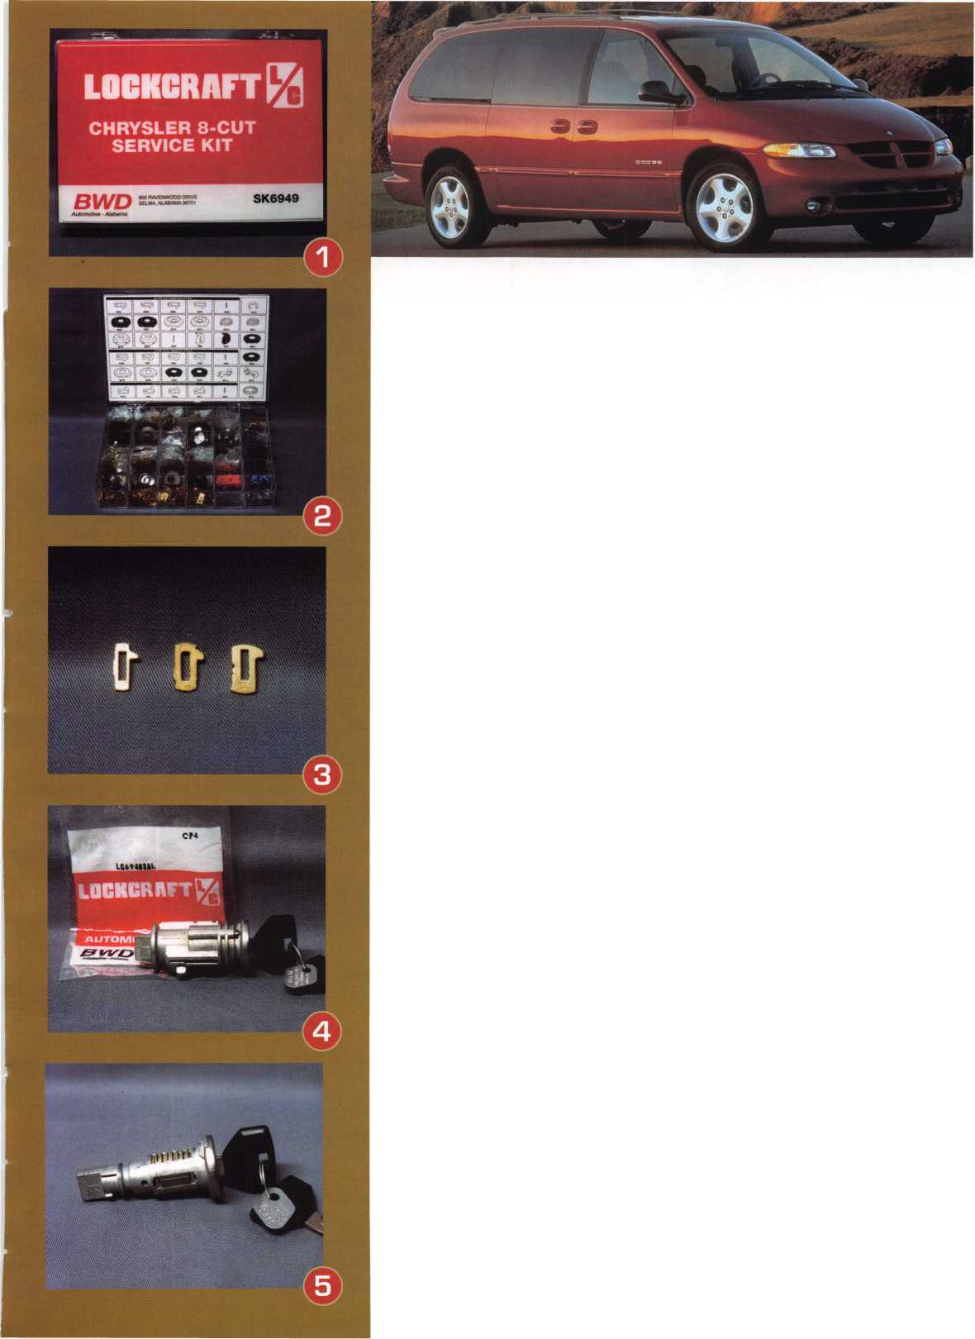

A .The Other Automotive

CustomersTTTT

By R.A. (Buddy) Logan

ASP has always tried to develop innovative sales programs for the industry. Your technical expertise is useless without customers!

While the general public is a very good customer base, locksmiths who wish to increase their automotive lock service and sales cannot rely only on the public. Locksmiths must pursue automotive trade customers who are now most likely buying their parts from the new car dealers.

The locksmith s main competitors in car lock sales and service are the new car dealers. We estimate that for sales directly to the car owners or independent repair shops who install the lock on the car, the new car dealers sell between 85% and 90% of the replacement car locks used today. So there is a lot of room for the locksmiths’ market to grow. But growth can only be accomplished by marketing and educating automotive trade customers.

It would do little good to try to educate the car owners. Unless a car owner has an immediate problem with one of his locks, he is very unlikely to remember anything he reads or hears today if he has a problem next week. Many car owners have been taught over the years that when something goes wrong with their car, the place to go is a car repair shop, or back to the dealer where they bought the car. A car lock problem is often thought of as a car repair job instead of a lock repair job. So locksmiths never get the first chance on many car lock repair jobs. But there is a second chance if the locksmith has educated the automotive repair shops where the car owners are bringing their cars for automotive lock service.

Specialists are common in the automotive trade. Services on auto upholstery, glass, radiators, fuel injection, etc. are often farmed out by general repair shops to specialists in those trades. In those instances the general repair shop is the customer of the specialty

shop. The car owner is the customer of the general repair shop. The general repair shop may remove the old part and replace it with a new or repaired part. The specialty shop does its job for the general repair shop at a discount price from the normal retail price of the service, usually 20% to 25%. The general repair shop charges the car owner the normal retail price of the service performed by the specialist, plus the labor for removing and replacing the part, etc. Automotive locksmiths should thus establish themselves as specialists in the same way as auto upholstery shops, auto glass shops, auto radiator shops, etc.

Automotive trade customers who offer the best potential for locksmiths are independent body shops and independent garages. The car owner may take the car to an independent body shop or garage, which buys the replace­ment lock from a dealer. The locksmith may get the opportunity to rekey the new lock to the original car key, although in many instances the car owner is still sent away with a separate key to fit only the new lock. Locksmiths should market their services as being a one-stop-shop for automotive lock needs. The locksmith should not have to settle for only rekeying new locks that the repair shops purchase elsewhere. The locksmith should be able to supply a new lock coded to the original car key as a one- step procedure. Even if the locksmith’s price for the parts is about the same as the price charged by the dealer, the convenience saves the repair shop time, which is money!

Used car dealers can also be a good source of business for the locksmith, especially with the recent development of Used Car Super­stores. It is increasingly important for these used car dealerships to offer only top quality vehicles. A damaged lock on a car, or a car with an odd key to fit only one replacement lock, is not consistent with the quality image that these dealerships need to portray. Of

course some used car dealerships offer lower quality cars as low cost transportation. These dealerships and the people who patronize them would often not care about the condition of the locks on a car. So when soliciting business from used car dealers, concentrate on the ones who specialize in selling late model high quality cars.

New car dealers offer fewer opportunities for the locksmith, although some locksmiths have very successful business with new car dealers. For various reasons, not necessarily including price, most new car dealers will buy replacement locks and parts only from their official supplier. Of course most new car dealers also have a used car department.

If, for example, the used car department at the Honda dealer has a traded-in Toyota with a damaged lock, this could be an opportunity for the locksmith. So when soliciting business from a new car dealer, be sure that the used car department is aware of all the services you can provide. You may not get any sales of parts for the dealership’s own brand, but you will likely get some business for other brands sold or serviced by the dealership.

Hopefully, you are excited about the business potential of these automotive trade customers, you need to know some rules of the game. To increase your chances of success with automotive trade accounts, you must be prepared to do business in the way that these companies are accustomed to doing business with their other suppliers. Here are some things that you must keep in mind:



PRICING

Auto repair shops are armed with flat rate manuals, parts prices, etc. The auto repair industry is built around giving cost estimates to the car owners before starting the job. In some cities and states written estimates for car repair are required by law. So the shops know how much a job is supposed to cost. You must be prepared to set your prices within the parameters of the flat rate manuals. Being too expensive will get you no work, and being too cheap could raise red flags as to the quality of the work you are performing. Do not expect to sell your services based solely on price. To most automotive trade accounts, value added services such as convenience, quick service, reliability, and quality are more important that the actual price. To these repair shops, an inconvenience or problem can create a

hidden cost that can mean the difference between a profit and a loss on a job.



DELIVERY SERVICE

Auto repair shops get free delivery from the car dealers and the parts wholesalers that they buy from. So they will expect free delivery from you. Of course, this does not mean that you have to drop what you are doing immediately when one of these customers calls you. There may be instances where this is needed by the customer, and depending upon the circumstances this could be a chargeable service call. But for normal non-emergency orders, work in the deliveries on the way to or from other service calls, on the way to the bank, on the way to lunch, etc. Schedule the deliveries in the way so that they do not create extra expense for you. Customers who give you work on a daily basis could be set up on a type of schedule. And if you generate enough of these customers, you could run a route once or twice a day. The volume of work will more than pay for the time and effort of the delivery service.



**BILLING**

You will probably need to offer 30 day accounts to these customers, as much for convenience as for financial reasons. The car dealers offer 30 day accounts to qualified repair shops. COD creates many more trans­actions for the shop’s bookkeeping department, making your service less attractive to the shop compared to the car dealer. Some of you may have heard that auto repair shops, car dealers, etc. are slow paying customers. This may be true for some, but there are a few bad apples in every basket. As in any trade, there are many more honest players than dishonest ones. Face it, a company which does not pay its suppliers cannot stay in business very long. Judge each potential customer on its own merits, and use common sense to make sure that the terms you extend to these customers are not abused.



PROMPT SERVICE

Buying replacement locks from the

dealers has been deeply ingrained into the auto repair shops. Offering potential customers service equal to what they have been getting from the car dealers may get

you very little results. You must be better than the dealers. Price is not a big issue, and for various reasons being lower priced may actually lose you business. You don’t want to give longer payment terms for the health of your own business.

But you can almost always have an edge over the car dealer in delivery time. Few car dealers keep lock cylinders in stock. It usually takes three to seven days for a car dealer to obtain a lock that they do not have in stock, plus the time required to recode the lock to the original car key. For car brands supplied by ASP, the distribution system offers you overnight delivery for most popular locks and parts. Less popular items can also be supplied in one to three days using the ASP HI- SPEED delivery program, whereby any part not in stock at your distributor is shipped directly to you from the ASP warehouse. Realistically you should keep a supply of popular parts in your own stock. This allows you to offer same day service on many jobs. It also allows you to buy in larger volume to lower your purchasing costs, increasing your profitability.

The auto repair trades are full of special­ists. You can be one of these specialists too! The keys to success are to adapt your business to the way the auto repair shops are accustomed to doing business, promote your capabilities, followed by reliable high quality service at reasonable prices.

ASP is preparing marketing assistance for locksmiths who are interested in making a commitment to servicing auto repair shop customers. Some of you may have completed a questionnaire that was circulated by ASP earlier this year. If you completed one of those questionnaires and indicated an interest in working with auto repair shop customers, you have not been forgotten. We are studying the data received from locksmiths who completed the questionnaire so that we can develop the best possible marketing programs for you. If you are interested but did not receive a questionnaire, please contact ASP for more information.

ASP may be contacted as follows: Telephone (425) 556-1900 FAX(425) 558-1205 US Mail: PO Box 10 E-Mail: [info@carlocks.com](mailto:info@carlocks.com) Redmond, WA 98073-0010 Internet site: HYPERLINK <http://www.carlocks.com>

October 1998

Keynotes

of the cornerstones of domestic automotive locksmith servicing is the use of progression techniques to originate keys. The General Motors progression technique is the most common and most useful method for generating an original key when there is no existing key or code information from which you can determine the key bitting configuration.

This method grew out of the need for a manner in which to generate a key quickly and efficiently to fit the trunk and door locks. The reason that this method developed was due to the fact that the glove compartment lock was combinated the same as the door and tmnk locks. Since the trunk and door locks are usually very difficult to access for disassembly and reassembly, the much easier access employed by the glove compartment made this lock the obvious choice

It is interesting to note at this point that there are still many professional locksmiths who are not familiar with this technique. Another group of locksmiths-those who are new to the industry— also need to see how useful this method can be if they choose to pursue domestic auto lock servicing as one of their areas of specialization.

There is neither the time nor the space in this article to review in detail all different varieties of glove compartment locks available on

**ral Motors**

**ESSION** 101

By Steven B. Spiwak, CRL

all the different makes and models of General Motors cars that have been produced over the last couple of decades or so. Therefore, we will begin our procedure with the step where we have the glove compartment lock cylinder plug in our hand after it has been removed from the lock cylinder housing.

For many years the disc tumblers available in the typical General Motors glove compartment lock cylinder were either color-coded or numbered. The numbers were inscribed or etched on each individual tumbler. In that case, the locksmith was only required to “read or decode” the tumblers to obtain the correct numerical key bitting configuration. In later years, there were no numbers or easily accessible codes, so the locksmith was required to insert the correct key blank into the glove compartment lock cylinder plug.

The only problem with this method for decoding was a simple mathematical one. The glove compartment lock cylinder contained only four disc tumblers while the door and trunk lock cylinders contain six tumblers. The exception being the rectangular sliding glove box lock used on many of the luxury GM models that incorporated a side bar plug containing all six tumblers.

The questions remained, “Could the locksmith determine the numerical value of the remaining two disc tumblers? And if the values could be determined, then how should the locksmith determine the numerical value of the remaining two disc tumblers?” In reality, the answer to this question proved to be simple and practical. The reason that this method is so easy to apply is due the fact that there are four rules that apply to all five depth General Motors keys.

1. **The numerical values of all six cut single-bitted General Motors keys must add up to an even total.**

For example, if the bittings were 1-3-4-5-3-2 then the total would = 18, an even number!

1. The MACS (Maximum Adjacent Cut Specification) is 2 or less. In other words, a 1 cut could be next to a 2- or 3-cut, but not next to a 4- or 5-cut, since in this case the difference would be 3 or 4 levels of difference.
2. There can never be four cuts of the same depth in a row on a key. This means that a key might contain the bitting: 5-3-3-3-5-3, but would not contain the bitting: 5-3-3-3-3-51
3. The same depth is never used more than four times in the same key. This means that a key might contain the bitting: 4-4-2-4-4-2. But would never contain the bitting: 4-4-2-4-4-4.

Keynotes

October 1998

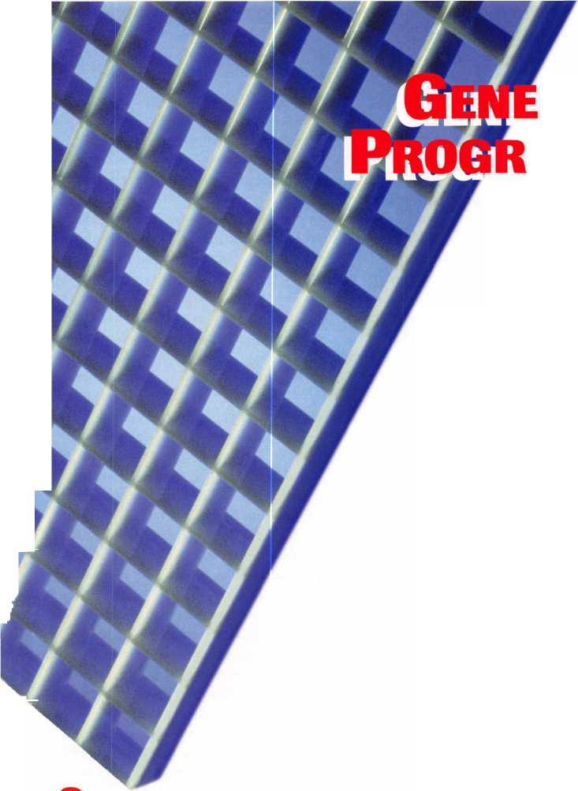

Armed with this information, the professional locksmith could find the following situation. The numerical values for the four disc tumblers are X-X-1 -1 -2-3.

This means that the total of the four known cut values is 1 + 1±2±3=7. Since seven is an odd number, the value of the remaining two cuts must also be an odd number. This is because an odd number and an odd number always add up to be an even number.

There is a mathematical formula to help us determine the total number of possible bittings that can be created from our two unknown bittings. That formula is T = Ds.

* T = the total number of possible bittings
* D = the depths in the system in question (GM features 5 depths)
* S = the spaces in question (in this case the 2 unknown spaces) Therefore, T = 52, or 5 x 5, or 25. There are 25 total possible

combinations for these two unknown cut positions. The following table lists the 25 possible 2-cut configurations, which are available. (NOTE: The comma has been eliminated from between the numerical key cut values for reasons of simplicity and expediency.) I Notice that we can use our four rules to eliminate many of these possibilities in order to simplify the process, so that in the end we have fewer choices from which to choose our correct combination, which will yield the correct key.

First we begin by eliminating any possibility of more than three bittings of the same depth in a row. This will eliminate 1-1.

Then we will eliminate any possibilities where the two numbep exceed our MACS of 2. This involves six possibilities. They are 4-1, 5-1, 1-4, 1-5 and 2-5. Our chart will now look like this. I Next we can reduce the usable number of bittings further by eliminating those possibilities where when the two numbers are combined they add up to an even number. This is true because when these two numbers are added to our existing four numbers the sum will be odd, which is unacceptable. For example, if we were to add the combination 4-2 to our existing 1-1-2-3, the result would be 13, an odd number, which is not acceptable.

We can therefore eliminate the following 11 possibilities^

11,13, 22, 24, 31, 33, 35,42,44, 53 and 55^

Our chart would now look like this. I Now we must look at our rules one more time. Notice that our known four number key cut bitting begins with a one. Therefore possibilities 34, 54, and 45 are unacceptable because a 4 cut or a 5 cut next to a one exceeds our MACS by 2. We are now left with the following 5 possibilities. I

All we have to do at this point is to plug in these values one at a time by using any type of code key machine or depth keys. Therefore our first key would be 1-2-1-1-2-3. Let us assume that this key does not operate the lock. Do not throw away this key. You must simply cut the first two cuts to a progressively deeper combination or the next sequence of numbers in the pattern (hence the name, progres­sion), namely: 2-3-1-1-2-3. If this fails to operate the lock, then try 4-3-1-1-2-3.

At this point, you must discard this key since you can no longer use it to cut the remaining two combinations, one of which will operate the lock. If the combination that you obtain is an even sum, then there are three strings of numbers, not just two and you can discard up to two keys before you determine the right combination. It should be pointed out that there are exceptions to this rule, but

|  |  |  |
| --- | --- | --- |
| / 11 | 12 13 14 15 |  |
| / 21 | 22 23 24 25 | fete. |
| / 31 | 32 33 34 35 | fete.. |
| / 41 | 42 43 44 45 | fete. |
| / 51 | 52 53 54 55 | fete. |
|  | 12 13 |  |
| / 21 | 22 23 24 | fete. |
| / 31 | 32 33 34 35 | fete. |
| / 42 43 44 45 | | |
|  |  | Sffe |
|  | 12 |  |
| 21 | 23 | fete. |
| 32 34 | | |
| 43 45 | | |
|  | - |  |
|  | 12 |  |
| 21 | 23 | fete |
| 32 | | |
| 43 | | |
|  |  | SSs, |
|  |  |  |

they are rare. Usually, the only time that this system does not succeed is when the lock cylinder tumblers have been changed previous by someone who either accidentally or on purpose chose not to follow the accepted pattern of key bitting generation from the factory.

I hope that this clarifies the General Motors Progression system for you. It is a useful system that you should be employing on a regular basis.

October 1998

Keynotes

**Thank you until next year to the ALOA Convention and Security Expo sponsors, exhibitors, instructors, volunteers and attendees.**

**You were the lifeof the party.**

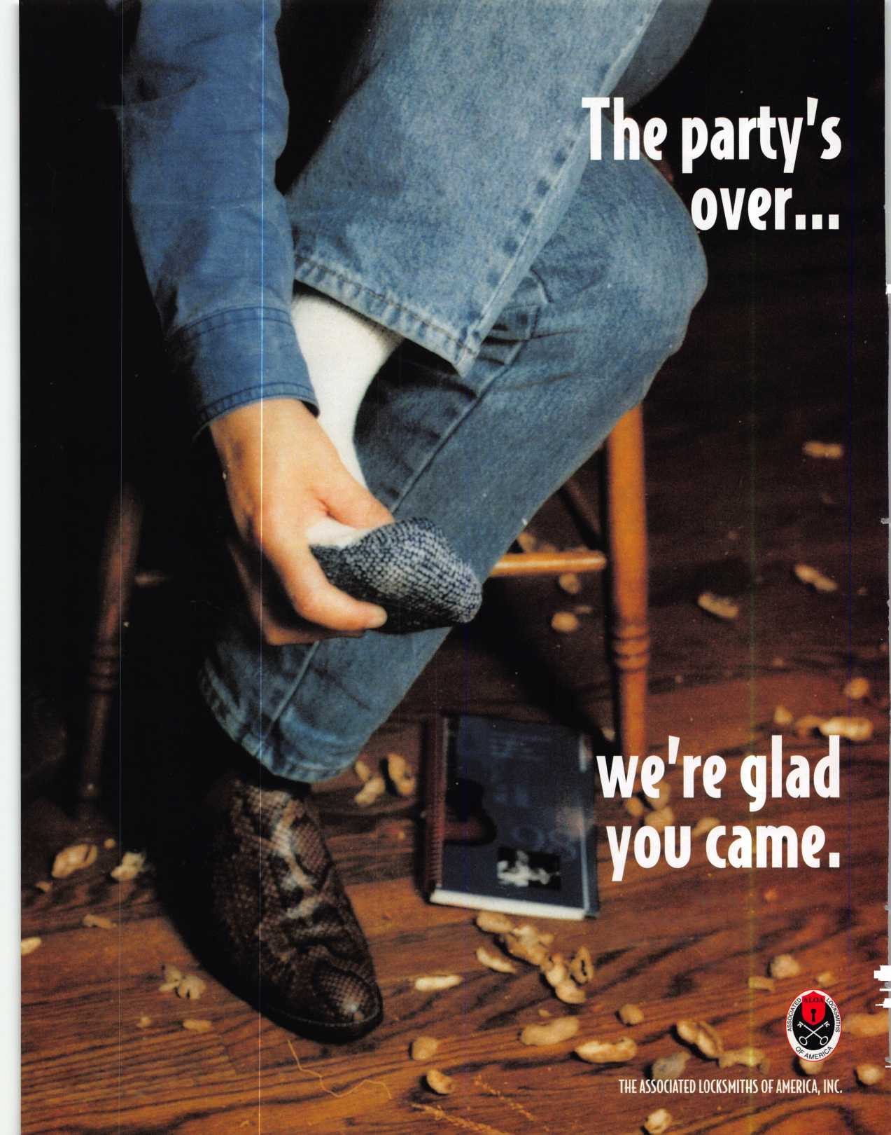

1

Motivating full time employees is hard enough. But part time workers pose a special challenge.

How do you light fires under people who are often saddled with low level work, blocked from climbing the corporate ladder, and treated like “outsiders” by the full time staff?

Answering that question has become critical. Slimmer profit margins are forcing more retailers to maintain smaller payrolls, while hiring part time employees for busy hours and temporary workers for peak seasons. Such “contin­gency workers” now account for 20 percent of Americas work force, according to the Chicago consulting firm of Towers Perrin. That’s expected to rise to 30 percent within a decade.

“Part time and temporary employees have become vital tools for keeping a retailer’s labor costs under control,” says Carl Johnson, president of Princeton Employee Relations,

Princeton, N.J.

Unmotivated part-time workers are dangerous.

Feeling demoralized, they perform in a listless manner and neglect customers. That threatens your profits. Worse, disenchanted part time workers are apt to quit for greener pastures. That saddles your shop with the costly task of training replacement workers.

Here’s some good news.

**| AVOID THESE ■**

**CQM**40**N**

**KU**

Giving them the cold shoulder.

Avoid the common mistake of parking new part time workers at a sales counter or a desk with a vague promise to “get back to them later.” Instead, give them a warm welcome when they arrive at your shop. Introduce them to the staff.

“It’s easy for part time workers to feel they are not wanted or needed or loved, so they don’t fit in,” says John Fanning, president of Uniforce Staffing, New Hyde Park, N.Y. “Treat the part time worker as a human being, not as a commodity.”

Avoid confusion and hurt feelings by clearly identifying the chain of command to the new employee. Who is authorized to give orders to the part time worker?

Turning them loose without orientation.

New part time workers can easily feel lost. They need to be oriented to the workplace “On arrival, take 15 minutes to describe job duties exactly,” says Bruce Steinberg, spokesman for the National Association of Temporary and Staffing Services in Alexandria, Va. “And cover basic things. What are the policies in the shop? Can they use the phone for personal calls? What are the policies on overtime? Who should they call if the copy machine breaks down? Who is their relief if they have a problem that needs to be covered at all times?”

You can motivate these employees. The secret? Avoid making common errors that are proven “turn offs” for part time and temporary workers.

Here are the most common errors to avoid, from leading management consultants:

**WHEN MANAGING  
PART-TIME  
EMPLOYEES**

by Phillip M. Perry

Plan ahead. “Do things

ahead of time,” says Steinberg.  
“Don’t just assume that when  
people show up you will get  
everything ready. Prepare their work  
space with all the tools they need.”

October 1998

Keynotes



**THE DIRTY DOZEN:**

**HOW TO REALLY TURN**

**OFF PART-TIME  
EMPLOYEES!**

1. Give them a cold shoulder.
2. Turn them loose without orientation
3. Leave them without a mentor.
4. “Mother hen” them to death.
5. Load them down with “grunt” tasks
6. Assign them only small units of  
   many projects.
7. Overlook work well done.
8. Allow conflicts with full time empl
9. Omit them from shop activities.
10. Omit financial incentives.
11. Insist on rigid work hours.
12. Ignore feedback after the job.

**HOWTO  
HIRE SMART**

“When you make a mistake hiring a  
part time person, it haunts you for a long  
time,” says Don Schackne, president of  
Personnel Management and Administra-  
tion Associates, Delaware, OH. “How do

you get rid of bad hires, and how do you  
replace them? Taking on the wrong  
person is a costly error.”

Here’s what to do before hiring:

Make sure you need  
a part time person.

Consider fully using your current staff  
by shifting work burdens around, or  
even eliminating some unnecessary tasks.

Allow plenty of time.

Don’t hire in panic. Anticipate  
your work loads and start the hiring  
process far in advance of the time you  
need the worker.

Use all resources.

Your best hires will come from  
referrals by current employees who  
know your business,” says Roy E.  
Chitwood, president of Max Sachs  
International, a consulting agency  
in Seattle, WA. “But you can also  
place classified ads and use  
temporary staffing firms, who  
make available individuals on a  
full and part time basis.”

Select a staffing firm carefully.

Does the staffing firm have a  
good compensation package,

training and selection process?

If not, this can

Not assigning a mentor.

Even with a good orientation, the new part time worker will soon feel confused. Full time staffers may be so busy that the new worker hesitates to approach them for advice. Result: the worker is demoralized and operates at less than peak. Solution: Assign a mentor to each part time worker.

“A mentor is a tremendous motivational tool,” says Don Schackne, president of Personnel Management and Administra­tion Associates, Delaware, Ohio.

“Select someone who is willing to teach and is patient. You can also assign a few permanent people as roving mentors. This is especially valuable in retailing where these people can roam the floor.”

The mentor will feel good about the

added responsibility.

Exerting too much control.

Managers tend to exert too much control  
over part time workers.

Maybe your shop has done things one way  
since time began. Does a better way exist?

You’ll never find out if you don’t give the new  
worker the freedom to try. You can increase  
motivation substantially by allowing the part  
timer to solve problems in creative ways.

“When part time workers believe they are  
making a difference in an organization, they feel  
better about being there,” says Ian Jacobsen,  
president of Jacobsen Consulting Group,  
Sunnyvale, CA.

Encourage everyone to think creatively

by recognizing new ideas publicly.

Loading down the part timers  
with “grunt” tasks.

“Lots of times, part timers are assigned the  
worst tasks that no one else wants to do,” says  
Ellen Wagner, president of Creative Solutions,  
Farmingdale, N.J.

“That’s demoralizing.”

It’s tempting to assign all of the low-level work to the part time worker and let things go at that. After all, doesn’t that free up your permanent employees for more productive work? Yes, but it can also demoralize your part timer to the point of quitting.

Remember, that everyone feels good about improving skills. What challenging tasks can you

assign to part time workers? To find out, ask them!  
What skills would they like to acquire? Perhaps,  
they want to learn about a line of merchandise,  
improve their sales approaches to customers, or  
learn display techniques.

By encouraging new skills you help match  
the employee’s personal goals with that of the  
retail business. This can foster the mutual loyalty  
that is a hallmark of good relationships with  
permanent employees, but that is often lacking  
with contingency workers.

There’s nothing wrong with assigning low level  
tasks. But just make sure you add some specialized  
skills to spark loyalty and enthusiasm by your part  
time workers.

Rotate the mundane tasks among all

employees to keep boredom at a minimum.

Assigning the worker only to small  
units of many projects.

It’s tempting to assign a part time worker to a  
wide range of projects.

For example, the same person may be assigned  
to ticket items in one department, check  
inventory in another department, stuff envelopes  
for a mailing another day. Watch out! That’s a good  
way to lose the worker to another employer.

“The employee will feel better about being  
able to bring a project to completion,” says  
Kenneth Misa, president of HR Consulting  
Group, Glendale, CA. “The work will be far  
more meaningful.”

This doesn’t mean that the worker cannot work  
on a series of unrelated projects. Just make sure  
that you also assign some complete project on a  
regular basis, so that the worker has a feeling  
of achievement.

Invite the part time worker to suggest a

project that will help the shop, then allow that  
employee to carry out the project.

Overlooking work well done.

Managers who recognize the achievements of full time employees will often neglect to congratu­late part timers. That’s devastating.

“The recognition of a job well done is even more important for part time workers,” says Dr. Peter A Spevak, director of the Center for Applied Motivation, Rockville, Md. “Their own identity with the company is not as strong and they need to be reinforced.”

Employees are more likely to feel they are “just



Keynotes

October 1998

part timers” if they are not given adequate praise  
for achievement. That leads to a lack of motivation.

Consider giving a plaque to the “Part Time

Worker of the Month” who has exhibited enterprise  
beyond the call of duty. Mount a series of photos of  
the winners on your employee bulletin board.

Allowing conflicts with  
full time employees.

Without proper communication, your full time  
employees may feel threatened by the part time  
workers. Fearing for their own jobs, your  
employees may give part time workers the cold  
shoulder, or fail to cooperate with them.

Solution: Explain to current workers why you  
are bringing in outsiders.

“Bring your full time employees together prior  
to the arrival of the part time people,” suggests  
Burt Slatas, director of marketing at Olsten  
Staffing Services, Melville, NY. “Explain your shop  
needs the help of part time staff to get the job done  
right. Communicate that the new people do not  
represent a threat to the jobs of the staff members.”

Reward successful referrals with cash bonuses.

Omitting part time workers from  
shop activities.

“Suppose you have a Saturday workshop” says  
Misa. “Why not invite the part time employees?”  
This will make them feel part of the team. “You  
should also invite them to employee lunches,  
parties, and any other activities in which the  
staff participates.

Hold an in-shop party for every part time

worker’s birthday.

Overlooking financial incentives.

Traditionally, bonuses have been reserved for  
full-time staffers.

Times are changing. Now, employers are setting  
up programs for part time people to stimulate  
enthusiasm for performance.

“Develop some kind of a bonus plan based upon  
gross sales or upon some performance-based  
criterion,” says Schackne.

Consider providing benefits for part time  
people,” says Roy E. Chitwood, president of  
Max Sacks International, a consulting agency in  
El Segundo, Calif.

“Typically they are excluded from normal  
benefit packages. After a certain amount of time



offer insurance coverage, or vacation time for number of hours of work put in.”

Pay part time workers a little more per hour

than competing shops. This will keep competitors  
from raiding your workers after you have invested  
in their training.

Insisting on rigid hours.

A substantial portion of part time and temporary employees are doing that form of work because they do not want to be tied down to nine- to-five hours. Some have children to care for and can have a problem finding sitters. Capitalize on that. If you allow for flexible hours you will encourage the employees to stay with your shop.

Avoid panic situations by encouraging employees to let the shop know in advance of any anticipated scheduling conflicts.

Get feedback after the job.

“At the conclusion of the assignment, give the part timer some opportunity to express feelings,” says Misa. “Have a brain storming session with the employees and the part timers. What was done well? Poorly?

“The answers can provide guideposts for improving your future treatment of part time workers and increase the return you get for your investment in their labor.”

Adds Spevak: “Get feedback, even if you do it formally with a checklist. This lets the workers know that you are pleased to have them as part of your team. It s a reinforcement.”

Offer a monthly award for the best tip on improving shop operations.

The tips in this article should help you  
motivate part time employees to work with  
more enthusiasm. That will put your  
business ahead of the competition.

“We have had a perception in the past  
that part time and temporary workers  
were disposable,” says Marc Silbert,  
spokesperson of Robert Half Interna-  
tional, Menlo Park, Calif. “They came,  
performed menial functions and left  
with little interaction.”

“Now, contingency workers serve  
virtually all aspects of the work place.

They should be recognized as the  
professionals they are.”

put a ceiling on the  
quality of the employee you  
acquire. Does the firm have a  
specialty? Ask for endorsements  
from satisfied clients. Use only one  
or two staffing firms. They will more  
likely send their best temps to  
steady clients and they get to know  
exactly what you need. Try to use the  
same part time and temporary  
employees on a regular basis. They  
will get to know your business and  
perform better.

Define your position precisely.

“When dealing with a staffing  
service, the single biggest error is not  
defining the position carefully  
enough,” says John Fanning, president  
of Uniforce Staffing, New Hyde, NY.

“The service needs that information to  
select the right person.”

Don’t over-hire.

A skilled individual will not be motivated by grunt work. “List the specific skills you need before interviewing for an individual,” suggests Burt Slatas, director of marketing at Olsten Staffing Services, Melville, NY. This is true whether you place your own classified ad or go to a staffing service.

Interview the person yourself.

Whether you place your own classified ads or rely on a staffing firm, interview the potential hire yourself.

“You’re looking for a self-starter,” says Carl Johnson, president of Princeton Employee Relations, Princeton, NJ. “The best way to determine that is to inquire about projects they have done. What innovations did they perform?”

During the interview process you should ascertain what it is about the job that appeals to the individual, says Johnson.

With that information you will know what buttons to push to motivate the individual.

**HOW TO PICK A STAFFING SERVICE**

Request a free brochure entitled How to Buy Temporary Help/Staffing Services.

Send a #10 self-addressed envelope with a 32 cent stamp to:

National Association of Temporary and Staffing Services, 119 S. Saint Asaph Street, Alexandria, VA 22314-3119 (Phone: 703-549-6287).

October 1998

Keynotes

If

Associate

Members

|  |  |
| --- | --- |
| Manufacturers | Arrow Lock Company  10300 Foster Avenue  Brooklyn, NY 11236 (718) 257-4700; FAX (718) 649-9097 |
|  | a a a a |
| A & B Safe Corp.  171 S. Delsea Dr.  Glassboro, NJ 08028 (800) 253-1267; FAX (609) 863-1208 | Auto Security Products (A. S. P.)  P.0. Box 10  Redmond, WA 98073-0010 (425) 556-1900; FAX (425) 558-1205 |
| (Q | a a |
| ASSA Inc.  10300 Foster Ave.  Brooklyn, NY 11236 (800) 235-7482; FAX (718) 257-2772 | BWD Automotive  900 Ravenwood Dr.  Selma, AL 36701  (334) 874-9001; FAX (334) 874-6011 |
| • | a a |
| Abus Lock Company  3555 Holly Lane North  Plymouth, MN 55447-0507 (800) 352-2287; FAX (612) 509-9939 | Chicago Lock Company  10100 88th Ave.  Pleasant Prairie, Wl 53158-0069 (800) 445-3204; FAX (414) 947-7178 |
| a | a |
| Adams Rite Manufacturing Co.  P.0. Box 1301  La Puente, CA 91749-1301 (562) 699-0511; FAX (562) 699-5094 | Corbin Russwin Architectural Hardware  P.0. Box 25288  Charlotte, NC 28229 (800) 543-3658; FAX (800) 447-6714 |
| a a | a a a a |
| Adesco Safe Manufacturing Co.  16720 S. Garfield Ave.  Paramount, CA 90723 (800) 821-6803; FAX (310) 408-6427 | Curtis Industries  6140 Parkland Blvd, Ste. 300  Mayfield Heights, OH 44124-4103 (800) 555-5397 |
| a | a a |
| Adrian Steel Company  906 James St.  Adrian, Ml 49221  (800) 677-2726; FAX (517) 265-5834 | DETEX  302 Detex Dr.  New Braunfels, TX 78130 (800) 729-3839; FAX (830) 620-6711 |
| a | a a a a |
| Alarm Lock Systems, Inc.  345 Bayview Ave.  Amityville, NY 11701 (800) ALA-LOCK; (516) 789-3383 | Don-Jo Manufacturing, Inc.  P.0. Box 929  Sterling, MA 01564 (508)422-3377; FAX (508) 422-3467 |
| a | a a |
| Aiphone Intercom Systems  1700-130th Avenue, NE  Bellevue, WA 98005 (206) 455-0510; FAX (206) 455-0071 | Door Controls International  2362 Bishop Circle East  Dexter, Ml 48130  (800)742-3634; FAX (800) 742-0410 |
| a a a | a a a a |
| American Lock Co.  3400 West Exchange Road  Crete, IL 60417-2099 (708) 534-2000; FAX (708) 534-0531 | ESP Lock Products, Inc.  375 Harvard Street  Leominster, MA 01453 (508) 537-6121; FAX (508) 537-1699 |
| a a | a |
| American Security Products (AMSEC)  11925 Pacific Ave.  Fontana, CA 92337-6963 (800) 423-1881; FAX (909)685-9685 | Folger Adam Security, Inc.  16300 W. 103rd Street  Lemont, IL 60439  (630) 739-3900; FAX (630) 739-6138 |
| a a | a a |
|  |  |



Associate members of the Associated Locksmiths of America (ALOA) manu­facture or distribute materials or equip­ment, or provide services, for the securi­ty industry. Many have donated money, services and equipment to ALOA in addition to their annual dues. Their sup­port of ALOA projects enhances overall membership benefits and we encourage our members to patronize these firms. If you know of a potential candidate for associate membership, please contact the ALOA Sales staff at (214) 827-1701. Associate member dues are $500 per year and entitle the payor to use the ALOA logo, and selected discounts on ALOA products and services.

Legend

Alarms: Personal, vehicle, electronic, fire, burglar, and exit

**V** Automotive: Lockout equipment, key chains/iings

1. Builders Hardware: Door closers, furniture/decorative hardware, viewers, emeigency exit devices

Books, reference guides, publications, computer software

9 CCTV/Photo Imaging: Cameras, monitors, photo ID equipment, cables

9 Electric/Electronic Security: Card access control and readers, surveil­lance, electric/magnetic locks and strikes, keypads

9 Lock Devices: Auto locks, cylinders, emeigency exit/entrance control, locks (various types), strikes

9 Tools A Supplies: Key blanks, cutters, picks, if ngs/hooks, custom van/truck

**ill *Keynotes***

October 1998

Reader Service

October 1998

|  |  |  |
| --- | --- | --- |
| am./\ Pienior |  |  |
|  |  |  |
| Name | PRP | ALOA# |
|  |  |  |

State

City

Years Experience

**Areas of Locksmithing that you are proficient** **i_n:.**

ODomestic Auto OCommercial OMaster Keying

OForeign Auto OResidential OAccess Control

OAuto Opening OSafe Servicing OSafe Opening

OCCTV OComputers OBusiness

Zip

Other

**Avai Lable** for **caLLsJ**

Phone numbers

Weekdays

Saturday

Sunday

AM tO AM tO AM tO

PM

PM

PM

Days

Nights

Pager

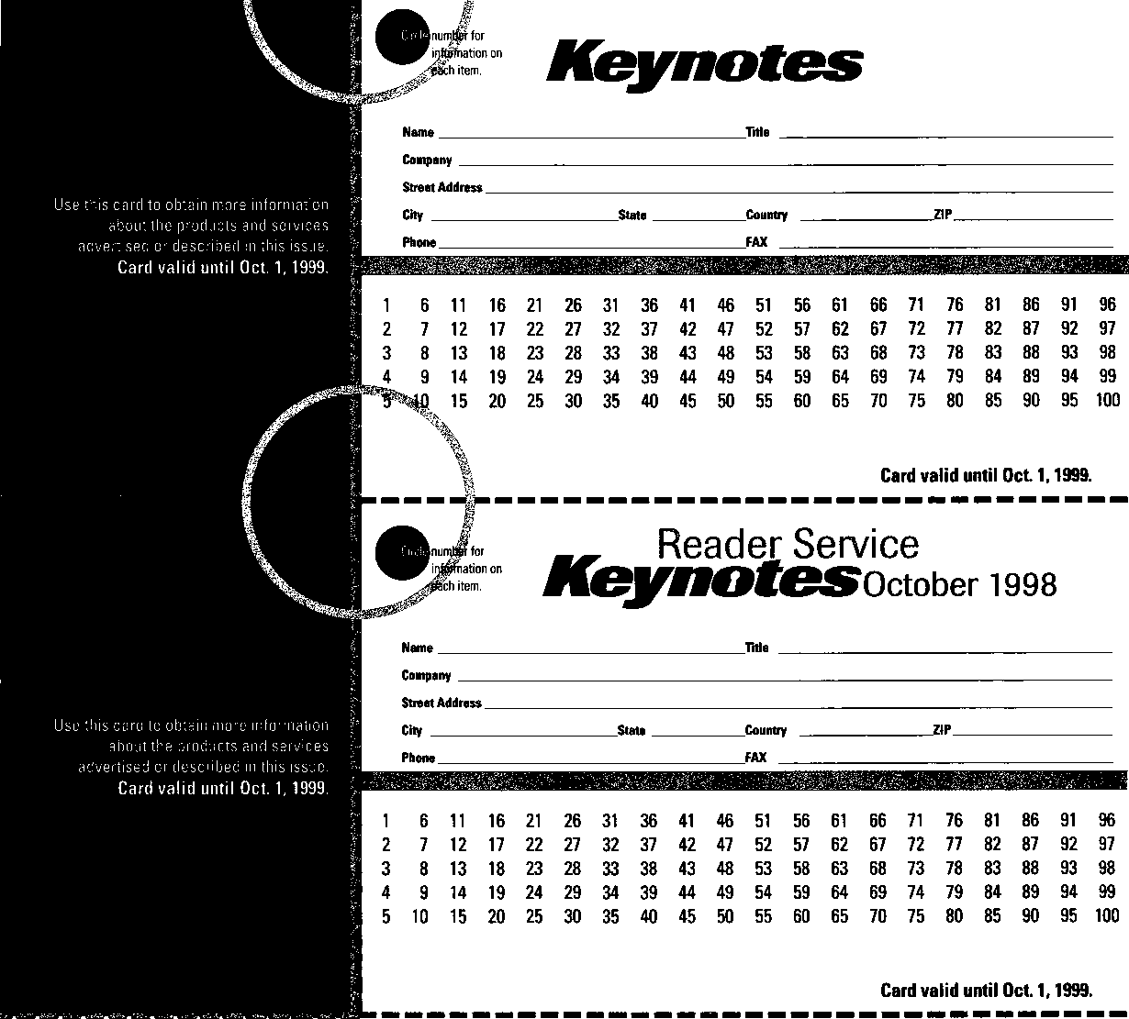

BUSINESS REPLY MAIL

**FIRST-CLASS MAIL PERMIT NO 16501 DALLAS TX**POSTAGE WILL BE PAID BY ADDRESSEE

NO POSTAGE  
NECESSARY  
IF MAILED  
IN THE

UNITED STATES

PO BOX 11602 RIVERTON NJ 08076-7202

UI..I.I

|  |  |  |  |  |  |
| --- | --- | --- | --- | --- | --- |
|  |  |  |  |  | NO POSTAGE NECESSARY  IF MAILED  IN THE  UNITED STATES |
| BUSINESS REPLY MAIL  FIRST-CLASS MAIL PERMIT N0 16501 DALLAS TX | | | |  |

POSTAGE WILL BE PAID BY ADDRESSEE

PO BOX 11602 RIVERTON NJ 08076-7202

Place

Stamp

Here

Robert DeWeese, CPL Bear Lock & Security, Inc. 205 Cleveland Ave. Baltimore, MD 21222-4237

|  |  |  |
| --- | --- | --- |
| Fort Lock Corp.  3000 N. River Rd.  River Grove, IL 60171 (708) 456-1100; FAX (708) 456-9476 | La Gard, Inc.  3330 Kashiwa Street  Torrance, CA 90505 (310) 325-5670; FAX (310)325-5615 | Rutherford Controls Inc.  2697 International Pkwy, Bid 5 #100  Virginia Beach, VA 23452 (757) 427-1230; FAX (804) 427-9549 |
| •••••• | • • • | • |
| Grobet File Co. of America  750 Washington Ave.  Carlstadt, NJ 07072 [800) 962-7242; FAX (800) 243-2432 | Lori Lock  P.O. Box 1040  Southington, CT 06489 (860) 621-3605; FAX (203) 621-5972 | STRATTEC Security Corp.  3333 W. Good Hope Rd.  Milwaukee, Wl 53209 (414) 247-3333; FAX (414) 247-3329 |
| • | • • | • • • |
| H.E.S., Inc.  2040 W. Quail Ave.  Phoenix, AZ 85027 (602) 582-4626; FAX (602) 582-4641 | Lucky Line Products  7890 Dunbrook Rd.  San Diego, CA 92126 (619) 549-6699; FAX (619) 549-0949 | Sargent & Greenleaf, Inc.  P.O. Box 930  Nicholasville, KY 40340-0930 (606) 885-9411; FAX (606) 887-2057 |
| • • • | • | iiii |
| HPC, Inc.  3999 N. 25th Avenue  Schiller Park, IL 60176 (847) 671-6280; FAX (847) 671-6343 | M.A.G. Engineering & Mfg. Inc.  15261 Transistor Lane  Huntington Beach, CA 92649 (714) 891-5100; FAX (714) 892-6845 | Schlage Lock Co.  1915 Jamboree Suite 165  Colorado Springs, CO 80920 (800) 847-1864; FAX (800) 452-0663 |
| • • • | • • • | • • |
| llco Unican  400 Jeffreys Road  Rocky Mount, NC 27804 (919) 446-3321; FAX (919) 446-4702 | MARKS USA  5300 New Horizons Blvd.  Amityville, NY 11701 (516) 225-5400; FAX (516) 225-6136 | Schwab Corporation  3000 Main St.  Lafayette, IN 47903-5088 (765) 447-9470; FAX (765) 447-8278 |
| ••••••• | • | • |
| In Out Systems, Inc.  3650-B Matte Boulevard  Brassard, Quebec J4Y-2Z2, Canada (514) 444-5949; FAX (514) 444-2029 | MUL-T-LOCK USA, Inc.  300-1 Route 17 South Suite A  Lodi, NJ 07644  (800) 562-3511; FAX (973) 778-4007 | Securitron Magnalock Corp.  550 Vista Blvd.  Sparks, NV 89434  (800) 624-5625; FAX (702) 355-5636 |
| • • | Mi | e • |
| Intellikey  551 S. Apolo Boulevard, Suite 204  Melbourne, Florida 32901 (800) 226-0703; FAX (407) 724-0811 | Master Lock Company  2600 North 32nd Street  Milwaukee, Wl 53211 (414) 444-2800; FAX (414) 449-3114 | Security Door Controls  3580 Willow Lane  Westlake Village, CA 91361 (805) 494-0622; FAX (800) 959-4732 |
|  | • • | • |
| Jet Hardware Mfg. Co.  800 Hinsdale Street  Brooklyn, NY 11207 (718) 257-9600; FAX (718) 257-0973 | Medeco Security Locks  P.O. Box 3075  Salem, VA 24153  (540)380-5000; FAX (540) 380-5010 | Security Solutions  1640 W. Hwy. 152  Mustang, OK 73064 (405) 376-1600; FAX (405) 376-6870 |
| • | • • • | • • |
| KABA High Security Locks  P.O. Box 490  Southington, CT 06489 (860) 621-3601; FAX (860) 621-9727 | Meilink Safe Company  111 Security Parkway  New Albany, IN 47150 (800) 634-5465; FAX (800) 896-6606 | Sentry Group  900 Linden Ave.  Rochester, NY 14625-2784 (716) 381-4900; FAX (716) 381-8559 |
| • | • | • |
| KEY-BAK; Div. of W. Coast Chain Mfg. Co.  1460 S. Balboa Ave.  Ontario, CA 91762 (909) 923-7800; FAX (909) 923-0024 | NKL Industries Ltd.  1111-13 Cavalier Blvd.  Chesapeake, VA 23323 (800) 528-9900; FAX (757) 485-0271 | Sully Tools Inc.  3515 Nodding Pine Ct.  Fairfax, VA 22033  (703) 689-3416; FAX (703) 787-0869 |
| • • • • | .• • • • | • • • |
| Knaack Manufacturing Co.  420 E. Terra Cotta Ave.  Crystal Lake, IL 60014 (800) 456-7865; FAX (815) 459-9097 | National Cabinet Lock  200 Old Mill Road, P. 0. Box 200  Mauldin, SC 29662 (864) 297-6655; FAX (864) 297-9987 | TIB Canada Ltd.  2164 Oneida Crescent  Mississauga, Ontario, Canada L5C IV6 (905) 566-9198; FAX (905) 566-9697 |
| • | • | ^ @ <0 |
| LAB Security  700 Emmett St.  Bristol, CT 06010  (800) 243-8242; FAX (203) 583-7838 | Newman Tonks  805 N Buckman St.  Shepardsville, KY 40165 (800) 826-5792; FAX (800) 777-8229 | Taymor Industries, Inc.  1586 Zephyr Ave.  Hayward, CA 94544 (800) 388-9887; FAX (800) 288-8133 |
| • | e # | • • |
| LCN Closers (Division of Ingersol)  121 W. Railroad Ave.  Princeton, IL 61356 (815) 875-3311; FAX (815) 875-3222 | ROFU International Corp.  2004-B 48th Ave.; Court E  Tacoma, WA 98424 (800) 255-7638; FAX (253) 922-1728 | Trine Products Corporation  1430 Ferris Place  Bronx, NY 10461  (718) 829-4796; FAX (718) 792-9127 |
| o | e | • • • |

October 1998

***Keynotes*** 135

|  |  |  |
| --- | --- | --- |
| Weiser Lock Company  6700 Weiser Lock Blvd.  Tucson, AZ 85746  (502) 741-6338; FAX (520) 741-6363  • a | DiMark International  3117 Liberator St., Unit A  Santa Maria, CA 93455 (800) 235-2435; FAX (805) 928-8034  a a | Hardware Agencies, Ltd.  1220 Dundas Street East  Toronto, ON M4M 1S3 (416) 462-1921; FAX (414) 462-1922 |
| Yale Security Inc.  P.0. Box 25288  Charlotte, NC 28229-8010 (800) 438-1951; FAX (800) 338-0965  • • • • | Dire’s Lock & Key Co.  2201 Broadway  Denver, CO 80205  (303) 294-0176; FAX (303) 294-0198 | Hardware Suppliers of America  P.O. Box 2208  Winterville, NC 28590 (800) 334-5625; FAX (800) 334-5635  a a |
| Zhongshan Hua Feng Lock Products  S Yongning Industrial Road, Ziaolan Zhongshan Guangdong, China  86-760 227 82 63; FAX 86-270 227 80 63  • | Direct Security Supply, Inc.  36 Lincoln Street  Boston, MA 02135 (800) 252-5757; FAX (800) 452-8600  ^ @ (|^ (p ^ | IDN, Inc.  1000 S. Main, Suite 280  Grapevine, TX 76051 (817)421-5470; FAX (817) 421-5468  aaaaaaaaaa |
| Distributors | Doyle Lock Supply  2211 W. River Road N.  Minneapolis, MN 55411 (800) 333-6953; FAX (612) 521-0166  aaaaaaaaaaa | Intermountain Lock & Supply Co  3106 South Main Street  Salt Lake City, Utah 84115 (800) 453-5386; FAX (801) 485-7205  aaaaaaaaaa |
| Accredited Lock Supply Co.  P.O. Box 1442  Secaucus, NJ 07096-1442 (800) 652-2835; FAX (201) 865-5031  ^ @ (0 (Q | Dugmore & Duncan Inc.  30 Pond Park Rd.  Hingham, MA 02043 (800) 225-1595; FAX (617) 740-4043  a a a a a a a | JLM Wholesale, Inc.  3095 Mullins Ct  Oxford, Ml 48371-1643 (800) 522-2940; FAX (800) 782-1160  a a a |
| Ace Lock & Security Supply Co.  565 Rahway Ave.  Union, NJ 07083-6631 (800) ACE-LOCK; (800) ACE-FAX4  •••••••• | E. L. Reinhardt Co., Inc.  3250 Fanum Road  Vadnais Heights, MN 55110 (800)328-1311; FAX (612)481-0166  a a a a a a | Jo-Van Distributors Inc.  929 Warden Ave.  Scarborough, Ontario MIL 4C6 (416) 752-7249; FAX (416) 752-3845 |
| Akron Hardware Consultants, Inc.  2579 South Arlington Road  Akron, OH 44319  (800) 321-9602; FAX (800) 328-6070  • 99 | Ewert Wholesale Hardware  4709 W 120th St  Alsip II 60658  (800) 451-0200; FAX (708) 597-0881  a a a a a | Lockmasters, Inc.  5085 Danville Road  Nicholasville KY, 40356 (606) 885-6041; FAX (606) 885-7093  a a a a |
| American Security Distribution  4411 E. La Palma  Anaheim, CA 92807 (714)996-0791; FAX (714) 579-3508  Q ^ ^ ^ | Fairway Supply, Inc.  2631 Lombardy Lane  Dallas, IX 75220  (214)350-0021; FAX (214) 352-4299  a a a a a a a | Locks Company  2050 N.E. 151 St.  N. Miami, FL 33162 (800) 288-0801; FAX (305) 949-3619  a a a a a a a |
| Andrews Wholesale Lock Supply  544 S. 9th St.  Lebanon, PA 17042-6608 (717) 272-7422; FAX (717) 274-8679  a | Foley-Belsaw Company  6301 Equitable Road  Kansas City, MO 64120 (800)821-3452; FAX (816) 483-5010  a a a a | The Locksmith Store Inc.  1229 E Algonquin Rd. Suite E  Arlington Heights, IL 60005 (847) 364-5111; FAX (847) 364-5125  a a a a |
| Boyle & Chase Inc.  P. 0. Box 74  Accord, MA 02018-0074 (800) 325-2530; FAX (781) 335-5342  a a a | Fried Brothers, Inc.  467 N. 7th St.  Philadelphia, PA 19123 (800) 523-2924; FAX (800) 541-3489  aaaaaaaaaa | M. Zion Company  69 Reade Street, 4th Floor  New York, NY 10007 (212) 349-8677; FAX (212) 964-0495  a a a a a a a |
| Clark Security Products, Inc.  4775 Viewridge Ave.  San Diego, CA 92123-1641 (800) 854-2088; FAX (619) 974-5284  aaaaaaaaaa | HS&S Wholesale Distributors  12915 West 8 Mile Road  Detroit, Ml 48235  (800) 521-2202; FAX (313) 342-7580  ^ @ (0 ^ | McDonald-DASH Locksmith Supply  5767 E. Shelby Dr.  Memphis, TN 38141 (800) 238-7541; FAX (901) 366-0005  aaaaaaaa |
| Cook’s Building Specialties  2441 Menaul Blvd. NE; P.O. Box 37320 Albuquerque, NM 87176-7320 (505)883-5701; FAX (505) 883-5704  a a a a a a | Hans Johnsen Company  8901 Chancellor Row  Dallas, TX 75247  (214) 879-1550; FAX (214) 879-1530 | McManus Locksmith Supply, Inc.  P.O. Box 9231,1309 Central Ave.  Charlotte, NC 28299 (702) 333-9112; FAX (704) 332-8664  a a a |
|  |  |  |
| ■ ■ ■ ' a Business/Tech & Ed. A T„„lc s. e..nnii<»  ■ a CCTV/Photo Imaging % Toote & ^pphes .. ..  ;... 0 Lock Devices | | |

***Keynotes***

October 1998

|  |  |
| --- | --- |
| McMaster-Carr Supply Company  600 County Line Rd,  Elmhurst IL 60126-2081 (630) 833-0300; FAX (630) 834-9427  •••••• | Service |
| Monaco Lock Co.  339-345 Newark Ave.  Jersey City, NJ 07302 (800) 526-6094; FAX (800) 845-LOCK  • • • | Alarm Monitoring Service, Inc.  5021 Fairfield St.  Metairie, LA 70006 (504) 454-2163; (504) 456-8737  • |
| Omaha Wholesale Hardware  1201 Pacific Street, PO Box 3628  Omaha, NE 68108 (800) 238-4566  •••••••• | Allstate Insurance Company  2775 Sanders Road, Suite A5  Northbrook, IL 60062 (847) 402-8196; FAX(847) 326-7509  • |
| Security Lock Distributors  40 A Street  Needham Heights, MA 02194 (800) 847-5625; FAX (800) 878-6400  • • • | GEICO  One Geico Blvd.  Fredericksburg, VA 22412 (540) 286-4399; FAX (540) 286-7106  • |
| Sentry Security Fasteners  8109 N. University  Peoria, IL 61615  (309) 693-2800; FAX (309) 693-2872  • • | The Hartford Financial Services Co.  55 Farmington Ave.; P.O. Box 2908  Hartford, CT 06104 (860) 520-2915; FAX (860) 520-2264  • |
| Southern Lock and Supply Co.  Box 1980,10910 Endeavor Way  Pinellas Park, FL 34664 (800) 237-2875; FAX: (800) 447-2299  ••••••••• | Locksmith Publishing Corp.  850 Busse Hwy.  Park Ridge, IL 60068 (847) 692-5940; FAX (847)692-4604  • |
| Stone & Berg Wholesale  99 Stafford Street  Worcester, MA 01603 (800) 225-7405; FAX (800) 535-5625 | The National Locksmith Magazine  1533 Burgundy Parkway  Streamwood, IL 60107 (630) 837-2044; FAX (630) 837-1210 |
| Strauss Safe & Lock Company  1801 Second Avenue  Des Moines, IA 50314 (515)288-9571; FAX: (515)288-9752  •••••• | Pine Technical College  1000 4th Street  Pine City, MN 55063 (800)521-7463; FAX (320) 629-7603  • |
| Timemaster, Inc.  127 SE 29th Street  Topeka, KS 66605  (785) 232-8705; FAX (800) 798-8463  ••••••• | Unlocks, Inc.  3505 Tarpon Woods Blvd. G409  Palm Harbor, FL 34685 (800) UNLOCKS; FAX (813) 787-7960 |
| Top Notch Distributors, Inc.  3151 GoniRd.  Carson City, NV 89706-7922 (800) 722-4210; FAX (800) 248-3620  • • • |  |
| Turn 10  P. O. Box 746  Marietta, OH m45750 (800) 848-9790; FAX (800) 391-4553  ^ (§) |
| U.S. Lock Corporation  77 Rodeo Drive  Brentwood, NY 11717 (800) 925-5000; FAX (800) 338-5625  • • • • • |
| Webster Safe & Lock Company, Inc.  3020 Millbranch  Memphis, TN 38116 (901) 332-2911; FAX (901) 332-2878  • •••••• |

It pays

to have new faces  
in the crowd.



During 1998  
each ALOA member  
who sponsors  
a new applicant  
will receive $40 cash  
(upon clearance,  
and payment of  
application fee and dues).

October 1998

***Keynotes*** lii

**Keynotes**

Classified



DeptJ

**j Classified Advertising Policy**

**Classified advertising space is provided free of charge to ALOA members, and for a fee of $.60 per word, $15 minimum for non-members. Classified ads may be used to advertise used merchandise and overstocked items for sale, “wanted to buy” items, business opportunities, employment opportunities/positions wanted and the like. Members or non-members wishing to advertise services or new merchandise for sale October purchase a “Commercial Classified Ad,” for a fee of $1.30 per word, with a minimum of $40. Each ad will run for two issues. For blind boxes there is a $5 charge to members and non-members. All ads must be submitted in writing to the ALOA office by the fifteenth of the month, two months prior to issue date. Send to Keynotes Classifieds, 3003 Live Oak St., Dallas TX 75204-6186. ALOA reserves the right to refuse any classified advertisement that it deems inappropri­ate according to the stated purpose of the classified advertising section.**

■ EMPLOYMENT Locksmith Wanted

10/F/3: Security Hardware Company over 100 years old is seeking quality technicians and inside/outside service. We pro­vide all types of hardware and locksmith services: mechanical, electronic, safe deposit, safe pen­etration, automotive. Great compensation packages, benefits profit sharing/401K. Building a strong culture of team players. Equal opportunity employer. Respond to:

Kenton Brothers, Inc.

Systems far Security 1718 Baltimore Kansas City, M0 64108 (816) 842-3700 (816) 471-1897 fax

Help Wanted

10/F/3: Liberty Lock and Safe has one position open to run the warehouse. Locksmith knowledge a must. Computer and inventory background a plus. Paid medical, vacation, holiday, 401K sick days. Pay D.O.E.

Fax resume to:

(702) 876-3470

Locksmith Wanted

10/F/3: Colorado’s largest lock­smith company seeks locksmiths with experience in impressioning, master keying and automotive. Top wages and benefits available for the right persons.

Send resume to:

Colorado Security Products, Inc. 3003 South Kipling Unit A-8 Littleton, CO 80127 or call:(303) 761-4899,

9 am to 3 pm MDT

Manager Wanted

10/F/6: Owner retiring. Will stay to help. Two vans (’95 Astro Ext. And 82 Chev G20 Van) in excellent condition. Owner will possibly finance with 35 percent down. Shop not for sale but it can be leased. Many extras. Too many to list. Many Government

Comm. Accounts statewide located in beautiful, busy and growing Missoula, Montana.

Call Peter at:

(406) 342-2472

Locksmith Wanted:

10/F/3: Coral Way Locksmith is looking for an all around experi­enced and honest locksmith with a professional attitude for inside and outside work. Knowledge of Access Control and Safes benefi­cial. We offer excellent work environment, competitive pat and he fellowship of a top notch professional team. We are a 15 plus employee locksmith and security company, aiming to be the biggest and best, in sunny Miami, Florida. Automotive work, clean driving record, good character and work references a must. Some nights and weekend work, bilingual a plus, but not necessary. We are looking to hire right now.

Call: (303) 227-1332 between 8:30 am - 6:30 pm EST.

Keying Technologist Wanted

10/F/3: Company is a major 250 million subsidiary of a major Fortune 500 firm in auto and related industries. The position is a new creation and the firm is looking for an individual with about seven years + business experience with or without a degree. Candidate should have a technological knowledge of key­ing systems (either key system order and/or safety lockouts for commercial or related cus- tomers.)A working expertise and familiarity of concurrent practices of manufacturing, manufacturing engineering, involving fabrica­tion and assembly processes to ensure compatibility of design and applications for manufactur­ing. Excellent compensation and benefit plans including 401K and full relocation package. Contact:

P. Goldram (904) 288-9143 (904) 288-8048fax P [Goldram@aol.com](mailto:Goldram@aol.com)

Locksmith Wanted

10/F/3: Established locksmith shop in operation 50 years with friendly staff looking for a quali­fied locksmith for outside road work. Knowledge and experi­ence in various areas of the industry. Safe opening knowledge essential. Minimum five years experience.

Professional attitude, organized, good communication skills and clean driving record. Benefits include pension, health insur­ance, paid vacation, holidays. Vehicle, tools. Two way radio provided. We’d like to have you join our team.

Fax resume and references to:

Dawn Barnes

(308) 366-8864

or mail to:

133 E. Main St. D12 Westborough, MA 01381

Locksmith Wanted

9/F/3: Tired of running calls and taking orders? Like to get off the road and take charge?

High volume lockshop seeking general manager. Applicant will be in charge of phone sales, dispatching, bids and proposals, etc. Great pay. Based on ability and knowledge.

Call: Mr Trotter (713) 322-3333 (713) 266-4330

Locksmiths Wanted

8/F/3: Largest locksmith in Las Vegas needs experienced locksmiths (two years mini­mum) for road technicians and counter help. Base salary plus generous commission program. This is a career opportunity with paid holidays and vacation, med­ical benefits, 401K plan and a great advancement potential. Resume to:

Liberty Lock & Key 3470 W. Sahara Las Vegas, NV 89102 (702) 876-3470 (702) 871-3397fax

Warehouse/Inventory Manager Wanted

9/F/2: Lock experience helpful. Will train.

Fax or send resume to:

Liberty Lock and Safe 3470 W. Sahara Ave.

Las Vegas, NV 89102 (702) 876-3470 fax

Locksmith Wanted

8/F/3: Work in Santa Cruz county. Two years minimum experience. Work inside and outside. Safe experience a plus. Paid vacation, sick leave and a retirement plan. Medical and dental coverage.

Resume to:

AA Safe and Lock Co. Inc.

712 Soquel Ave.

Santa Cruz, CA 93062 (831) 423-3487 (831) 438-2030fax

Automotive Locksmith

8/F/3: Relocate to South Florida and throw away your deadbolts and three keys for a dollar. We run over 300 calls per week.

You must own a truck with tools and code equipment to cut all foreign and domestic keys. You can earn $800 to $1500 per week. Truck and tools required. Inquiries to:

South Florida Lock and Safe (800) 928-2926

■ BUSINESSES FOR SALE Mobile Business For Sale

10/F/3: Live and Work in paradise. Established mobile locksmith business grossing $75,000.00 plus mostly commercial accounts, automo­tive and emergency service. Enormous growth potential for the right person. Completely equipped Ford E350 high-rise service vehicle, five key machines, safe service equip­ment, numerous books and manuals, computerized codes, tools to numerous to list. $45,000 takes it all.

Fax inquiries to: (303) 294-7990 or email to: [safetech@conch.net](mailto:safetech@conch.net)

Keynotes

October 1998

Locksmith Shop For Sale

9/F/3: Very profitable, estab­lished 26 years. Located in one of the fastest growing cities in North Florida. Ideal for hands- on owner.

Call: Business Resource Services (800) 881-8823

For Sale:

9/F/3: Fastest growing community in beautiful northern New Mexico. Owner retiring. Ski resort town located in Sangre De Cristo mountains (close to Colorado border). No competi­tion. Service area includes three resort towns. Excellent opportu­nity to expand into security sys­tem installations. Owner will stay on as needed to ensure smooth transition. Asking $40,000. Includes all equipment, inventory. Reasonable rent. **Respond to:**

Angel Fire Lock and Key Box 411

Angel Fire NM 87710 (303) 377-8873 afl&K@afweb. com [www.angelfirenm](http://www.angelfirenm). com

Mobile Lock Shop

8/F/3:1986 Dodge D150 with 318 and rebuilt tansmission and beefed-up suspension. HPC 1200 CN and Ilco 025 duplicator gas generator, countertop workbench. Ideal for beginner or as backup truck. Priced to sell. Sale price based on equipment or merchandise included on sale. Serious inquiries only.

Call: (913) 330-3397

For Sale

9/F/3: Full service locksmith shop in Southern California serv­ing the Beaumont/Banning area for over 26 years. Includes equipment, inventory, commer­cial accounts and 1984 1/2 ton Ford van. 1800 sq. ft. Building also available for lease or for sale. Owner can stay on for transition. Call (909) 845-5397 for details or leave message.

Inquiries to: Duane A. “Dewey” Miller (ALOA 16384)

Four Winds Lockshoppe 909 E. Sixth St.

Beaumont, CA 92223

Locksmith Business For Sale

8/F/3: Locksmith business in South Florida. Same location since in 1972. Owners are retir­ing. Established commercial accounts, including automotive, safe and residential work. Three service vans equipped with HPC

1200s sidewinder machine and computer system. The building has plenty of off street parking, showroom and a two bay garage with working vehicle lift. Build­ing lease is assumable. Owners will stay and assist buyer as needed. The shop currently has seven employees. $125K annual gross. Selling price - $125K - includes all stock and machinery. Serious inquiries only.

Call: (303) 681-3813

For Sale:

Mobile Lock Business

8/F/3: Due to illness complete mobile lock business for sale.

30 year plus customer base. **Inquiries to:**

Bob’s Lock and Key Service PO Box 473

LaPorte, TX 77372-0473 (281) 471-6283 or (281) 471-0880

For Sale

8/F/3: Experienced locksmith company in Westchester County, NY with a strong commercial following with yearly sales in excess of $800,000. Overhead is reasonable and store is equipped with the latest vehicles and equipment.

Contact: Ray Cotrufo (914) 332-1223 daytime (914) 946-3933 nighttime email: [cotrufo@banet.net](mailto:cotrufo@banet.net)

Locksmith Business for Sale

9/F/3: Well established lock­smith business, many commer­cial and industrial accounts, resi­dential and automotive work are also a part of this very successful shop. Established in 1971, we have continued to grow reaching a $180K Gross. Located in cen­tral Wisconsin near good fish­ing, hunting and recreational areas. This community is grow­ing, with a strong base of indus­try, large office complexes and a state university. Our service area is unlimited in the surrounding counties. This is the right opportunity for the right indi­vidual. Owner wants to retire, but will stay on for a smooth transition. The asking price is negotiable according to equip­ment and vehicles desired.

Call: (713) 341-9163

■ JOBS WANTED Position Wanted

9/F/3: Over 20 years OEM elec­tronics sales, sales management and marketing including distri­bution, rep. and manufacturer. Seven years distribution and direct factory sales in the securi­

ty industry. Seeking position in access control/electronic security marketplace. Mid Atlantic based with no travel restrictions. Resume on request.

All inquiries to: **Keynotes** 3003 Live Oak Dallas, TX 73204 (214)827-1701 (214) 827-1810fax

■ WANTED TO BUY/SELL For Sale

10/F/3: For sale or trade for boat, jet skis, or RV, I have safe open­ing equipment including and ITL Dialer, three hammer drills, two Bosch Hornets with Rigs, two ESI Boroscopes,

Sure-Vue Supreme with Halogen Light Source, In-A- Floor Puller, Diebold 175-70 pick with locks and parts, safe lock templates, drill bits, dials, miscellaneous hand tools, tech pubs and manuals (McOmie, National Safe Opening Guides, SAVTA, Tru-Center, Wills, National Safeman, Willis, Tidel, Fiche-Bauche, Lord, Diebold, Mosler, Safeman Guides, HPC Safe and Vault, Manipulation, Safe Deposit and SAVTA maga­zines. Approximately $13,000 total value.

For complete list, contact:

Bob Lawrence, CML 1067 Waterville Lake Rd.

Chula Vista, CA 91913 (619) 482-7142

cherybob @ worldnet. att. net

For Sale

10/F/3: Used Diebold Round door burglary resistant chest (25x25"x26") - $1,100. Used Safety Deposit Boxes also. One bank of 42 boxes (2"x5") - $500. Three banks of 60 boxes (2"x5")

- $900. One bank of 70 boxes (2"x5"). One bank of 10 boxes (5"x5"), One bank of 15 boxes (2 l/2"xl0"), One bank of five boxes (5" x 10") - $1,500.

One bank of 30 boxes (2" x 5"), One bank of 20 boxes (3" x 5"), One bank of 15 boxes (3" xlO"), One bank of five boxes (5" x 10"). One bank of five boxes (10" x 10").

Call: (423) 238-8143

For Sale

9/F/3: Silca Bravo Duplicator (like new) - $750; 1-HPC 1200 Code (like new) $1200; 1-HPC 1200 Code (Good Condition) - $1,000; HPC 3333 Duplicator (Carbide Cutter like new) - $850; Miscellaneous pinning kits (call for specifics).

Call: (801) 323-8609

For Sale

9/F/3: Collection of antique mortise and pipe keys (most over 100 years old). Approximately 324 keys plus six antique British mortise key safelocks. $2,500 or best offer.

Call: (319) 428-9242

Wanted

8/F/3: Rollift safe dolly, new or used. Please advise of condition. **Contact:**

Ronnie at John’s Lock and Safe (301) 484-7800

For Sale

8/F/3: Diebold 17505 S.D. Locks, W/Z Working Renter Keys - $12.00 each **Call: 602-921-0123**

For Sale

8/F/3: A veteran Israeli plant, since 1935, in field of locks, which manufactures parking posts for secure parking, heavy steel barriers that provide maxi­mum security against thefts, as well as an additional variety of protective devices against car theft, is seeking agents and dis­tributors for its products. The products are of superior quality, with a beautiful finish and at

Original Keyblanks for Sale

8/F/3: Trimark, Kryptonite,

Mobella, Yanmar, Southco,

Hudson Local, Haworth Desk Lock, U-haul padlock. Also available Golf cart pre-cut keys. **Inquiries to: Odd Keyblanks, Inc.**

(407) 774- 0100 (407) 774-6034 fax

For Sale

8/F/3: Retired CML has quality items for sale. Pin kits, hand tools, machines, safe tools, etc. Safe parts and other inventory. No junk.

Items are located in southwest United States.

Send self-addressed stamped envelope to:

3003 Live Oak Street Dallas, TX 73204

**M** COMMERCIAL CLASSIFIEDS For Sale

6/P/3: Aero Lock makes and sells

the finest tryout key, cut key and depth key sets in the industry.

Call or write for free catalog.

Aero Lock

3673 New Getwell Rd. **# 9** Memphis, TN 38118-6033 (800) 627-9433

October 1998 Keynotes | 39

**attractive prices.** Contact: Joseph 972-3-6837228fax

Buyer's

Guide

-Ad

AABLE Locksmiths

Well once  
again GM has  
come out with

another ignition lock design, and Frank  
Markisello from AABLE locksmiths has  
designed a tool to simplify the removal and  
replacement of this new lock. His tool kit  
will allow you to remove a steel face cap in  
seconds. Then with the drill guide tool you  
can drill an access hole in line with the side  
bar without hitting the hard plate or the side  
bar. Then you can rake the side bar in, so you  
can turn cylinder to the “on” position for fast  
removal. Then just replace the cap and  
reinstall same lock. The first job will more  
than save you the cost of the tool kit! Contact  
Frank Markisello at (718) 847-1377.

Reader Service #26

Alternative Tools

Here are new tools that  
address problems from an  
alternative point of view.

When the “usual” methods  
can’t get it done, try an  
alternative tool. “The Tool”  
tension wrench is designed

especially to allow more room for picks in  
SCI and KW1 keyways. “Lever Up” lifts  
vertical auto lock linkage without disconnect  
danger and without the tool entering the  
vehicle. “Paddle Pusher” operates paddles  
and crash bars like you were standing inside.  
$12.93 each (+$4.95 S/H). Allow four to  
six weeks for delivery. Send order on back  
of business card with check or m/o to:  
Alternative Tools, Inc.; 162 Robin Dr.;

Loveland, CO 80537.

Reader Service #27

BWD

BWD Automotive  
announces the new  
Lockcraft brand  
LC6177(U) and LC6180  
Ford 8-Cut ignitions and

SK6949 Chrysler 8-Cut Service Kit. Fitting  
virtually all 8-Cut vehicles, the new  
Lockcraft LC6177 (U) and LC6180 ignitions  
fit both transponder and non-transponder  
equipped Fords. The LC6177 is a coded lock

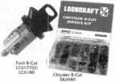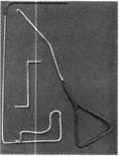

401_

supplied with non-transponder keys. The  
LC6180 is the same lock supplied with two  
transponder keys. The uncoded LC6l77U’s  
one-lock-fits-all feature, minimizes inventory  
and eliminates vehicle application problems.  
Warranty terms and conditions available  
upon request Contact (334) 874-9001.

Reader Service #28

Lucky Line Products, Inc

Stock the most  
affordable key organizer  
available — the Lucky  
Line Key Organizer  
No.61000. Made of  
shatter-resistant

polypropylene, this rugged key cabinet hold  
up to 24 keys. The product installs in  
minutes (screws provided). It measures 8-  
1/2'W x 10-1/2"H x 1 3/4"D and is perfect  
for home, office or garage. Contact:

(800) 654-6409.

Reader Service #29

Milman Manufacturing

Customize your key  
chains to advertise  
your store, company  
or club. Simply send  
us your logo, artwork  
or design and we’ll do

the rest. Contact: (514) 425-5794;

FAX (514)425-5793.

Reader Service #30

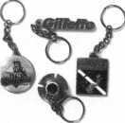

Back Page

Answers to Crossword Puzzle on page **44.**

ACROSS

1. Reds
2. Krohn
3. Five Star Chili
4. Carew Tower
5. Taft Museum

DOWN

1. Kings Island
2. Findley Market
3. Turfway Park
4. Bengals
5. Riverfront

Rutherford Control Inc

The Cabinet Lock  
is the ideal lock to use  
in small areas—and it  
takes only one second  
to reverse from failed

locked to failed unlocked! Because the lock’s  
catch bolt can be mounted on the side or the  
top of the lock, its flexibility is almost  
endless—applications include jewelry cases,  
key cabinets, drug cabinets, cash drawers,  
access hatches and more. An optional  
monitoring switch is another feature which  
allows even greater application versatility.  
This compact, dual voltage lock features 100  
lbs. holding force. Contact (800) 899-5625.

Reader Service #31

Slydelock Canada

Slydelock Canada is  
proud to introduce the  
SLYDELOCK. This  
unique design is  
engineered to securely  
lock your patio doors in  
its tracks. Made of lexan

plastic and reinforced aluminum alloy  
tubing, the SLYDELOCK lets you “lock  
open” your door by 5 inches. SLYDELOCK  
offers a life time product guarantee. Contact  
Gilles Pariseaw at (819) 770-1020.

Reader Service #32

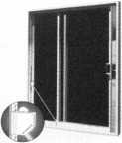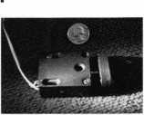

|  |  |
| --- | --- |
| 1  Keynotes Advertisers Index | |
| vf ■;  RS# Advertiser | Page |
| 5 Abus | _ 41 |
| 7 BWD | _ 42 |
| 100 Jet Flardware Mfg., Inc. | BC |
| 6 KSP | _ 42 |
| 3 Locksmith Publishing Corp. _ | _ 15 |
| 8 Security Technology & Design | 43 |
| 4 Strattec | 29 |
| 1 Timemaster | 6 |
| 2 Yankee | 9 |
|  | |

Keynotes

October 1998

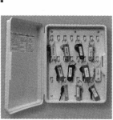

|  |  |
| --- | --- |
| >T< 1 | Tips _ _ _ _ _ |
| Trade |  |
|  | ■ |

How To Become A Trade Tipper

Each month, the Associated Lock­smiths of America (ALOA) holds a “Trade Tips” contest in Keynotes for ALOA members. In addition to helping other locksmiths by sharing your knowledge, there are three levels of prizes to be awarded:

Authors of any Trade Tip  
published will receive $20.

Monthly Prize for the  
best Trade Tip is $100.

The Grand Prize for the best Trade Tip of the Year is an expense-paid trip to the ALOA ’99 Security Expo

Each year, the ALOA Publications Committee selects one outstanding tip, the author of which receives a seven-day ALOA convention package that includes travel within the conti­nental United States and accommo­dations.

Want to Participate?

Mail your best idea (including photos,

illustrations or parts, if necessary) to:

Keynotes

Trade Tips Editor

3003 Live Oak St.

Dallas, TX, 75204-6186.

All entries are sent to the Trade Tips editor with the author’s identity delet­ed. The tips must be submitted exclu­sively to Keynotes and become the exclusive property of ALOA. Tips are judged on the basis of accuracy, pro­fessionalism, ethical standards, origi­nality and usefulness.

This month, we decided to do something a little different. We recently received a copy of the Texas Locksmith Associations Newsletter which had some great “Tricks of the Trade” printed in it.

But don’t think this means that we’re not accepting Trade Tips submissions. Think up the best ones possible and send them in!

windshield with their name and when to change my oil next. I went to the printer and ordered 500 for about 10 cents each, now after finishing a lockout or making keys for a car, I put my sticker in the windshield on the driver side. You can read my name and phone number from outside the car, I have gotten very positive responses for this!

A Delicious Cleaner for Tarnished Keyblanks:

Great for tarnished keyblanks, etc. Use unsweetened Kool-aid as a solution to clean brass. To use, follow directions on packet for amount of water to add (do not use sugar). Place brass keys and such into the mixture and brass products will almost immediately become clean. Use the lemon or lime flavor as it will not tint the brass keys like some of the strawberry fruit punch flavors will.

A Sticky Situation

While recently changing the oil in my auto, I noticed the static sticker on my

Last month’s Trade Tips winner was Vic-  
tor Virgil #024734 for “Pluggin’ Away.”

Trade Tips editor:

David Lowell, CML, CMS, is

the PRP/education manager for ALOA. He also  
serves as technical editor for Keynotes. Active for  
many years in ALOA leadership, David owns  
Phoenix Lock & Key in Arizona.

About the



Now Our  
Diskus Is  
Rekeyable!

"Urban

Diskus® is

available in a

rekeyable

the 24RK/70. An

stainless steel lock

and inner mechanism make

to attacks by boltcutters, hacksaws, pry bars, and  
hammers. The shackle is chrome hardened moly  
steel that's even tougher than our boron steel

shackle, and it's double deadlocked for additional

strength. The body of this Diskus® is a solid 2.2 mm

thick. Compare that to cheap knockoffs, that are only

around 1.5 mm thick. You can remove

The "key" difference this lock's cylinder in only 3 seconds.

the "go to" padlock when you need  
maximum security, with real resis-  
tance to harsh environments. It has  
been tested to over 6,000 lbs of

pulling force. And the patented design

in this Diskus® is its rekeyable cylinder.

CUP

The rekeyable 5-pin tumbler cylinder

truly makes our Diskus® the best solu-

tion for your most difficult security  
problems.

The Diskus® 24RK/70 and repinning

of the new rekeyable Diskus® is virtually impervious kits are available at full-line ABUS distributors.

**Made in Germany • ISQ-9000 certified**

ABUS Lock, USA 3555 Holly Lane North Plymouth, MN 55447-0507 800-352-2287

Contact any of these full-line ABUS distributors for same-day shipment!

Accredited Lock & Supply

East Coast 800-652-2835

Clark Security Products

New England 800-746-5625

Washington, DC 800-578-5625  
Denver 800-282-5625

San Diego 800-854-2088

Chicago 800-755-5625

Seattle 800-942-5275

|  |  |  |
| --- | --- | --- |
| Bells Security  East Coast | 800-772 | 2266 |
| IDN - Hardware Sales | |  |
| Livonia | 800-521 | 0955 |
| Locks Company  Miami | 800-288 | 2801 |
| McDonald Dash  Southern States | 800-238 | 7541 |
| Fairway Supply | 800-766 | 3247 |

R & H Supply

Northern CA 800-367-5625

Stone & Berg

New England 800-225-7405

Worldwide Lock Supply  
Los Angeles 800-729-5444

Zipf Lock Company

Ohio Valley 800-848-1 577

**Call toll-free: 1-800-352-2287 Visit our Web site: <http://www.abus.com>**

Reader Service #5

October 1998

Keynotes

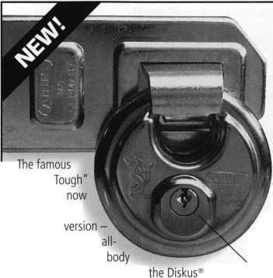

INTERCHANGEABLE  
CORE PRODUCTS

Interchangeable

with:

* best
* ARROW to f m
* FALCON

Quality • Price Delivery

That's what KSP is all about!

KILLEEN SECURITY  
PRODUCTS

Ask your wholesaler about  
our drop shipping.

***33 Harmon St.  
Worcester, IUA 01610  
Phone (508) 798-3200  
Fax (508) 753-2183***

Reader Sewice #6

Keys

Locks

Kits

Training

Certification

For a FREE VATSmith information packet and  
locations of BWD Certified VATS Centers  
Call

See us at [www.alllock.com](http://www.alllock.com)

Reader Service #7

Keynotes

Authors



Authors featured in this issue of

Keynotes:

I Sal Dulcamaro,

CML, has hem in the locksmith  
business for over 23 years. He is the  
presidmt of All Pro Security, Inc. in  
Michigan and has hem an ALOA  
member for 16 years. A past presidmt  
of the Locksmith Security Association  
of Michigan. Sal currently serves as  
editor of the association newsletter. He  
was named "Keynotes Author of the  
Year” for 1996 and 1997.



Mike Emery is

the associate editor of Keynotes  
and a freelance music, video and

real estate writer.

Phillip M. Perry has hem honored by the American Ear Association with its uValue to the Reader Award” for editorial achievemmt. His legal column appears in Folio:

The Magazine for Magazine Management and Editor & Publisher.

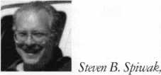

CRL, is a fourth generation locksmith who specializes in a variety of areas including crime prevmtion and institu­tional security. His broad experience in the security field spans 20 years of writing, teaching and consulting for a number of corporations. Most recently he formed Lockport, Inc.—a security consulting company for industrial, commercial, institutional and governmental climts.

Fred Kosloske is the OEM and Aftermarket Sales Manager for STRATTEC Security Corporation.

R.A. (Buddy) Logan is presidmt of ASP, Inc.



Tim McMullm

oversees govemmmtal affairs for  
ALOA as well as acting as the liaison  
to ALOA chapters and regional  
associations. He is a graduate of  
the District of Columbia School of  
Law and has an extensive background  
in legislative work.

Keynotes

October 1998

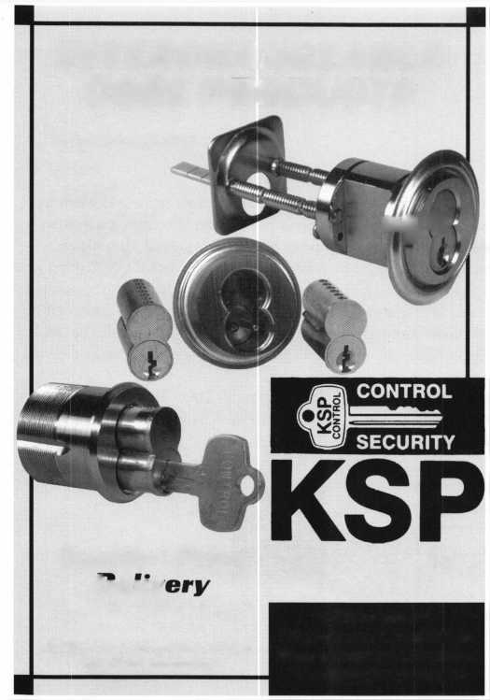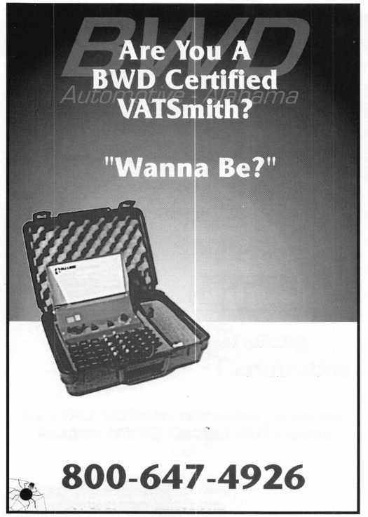

File Edit View Go Favorites Help

Address: | <http://www.ourcompany.com/home.htm/>

**ASSOCIATION**

H 0 M E P

Members

Benefits

Network

News

Z **[www.ourcompany.com](http://www.ourcompany.com)**

**BEG**

**Welcome to**

OiO



Reader Service #8

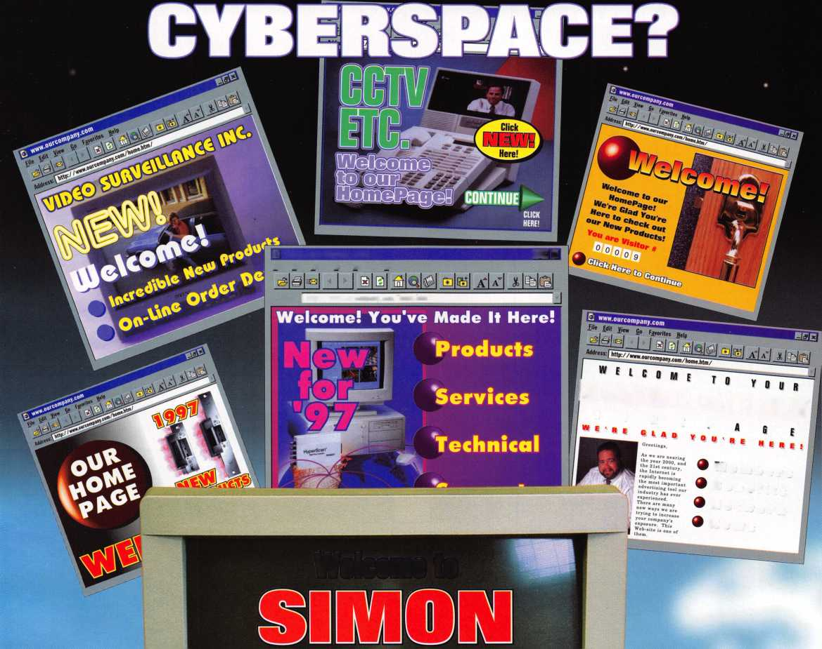

**Check your C.Q.**

**(Cincinnati Quotient, that is...)**

ACROSS

1. “Colorful” baseball team
2. Famous conservatory
3. The “hottest” dish in town
4. Famous observatory
5. Institution named for 27th

DOWN

1. Amusement park for a “royal good time”
2. Open air bazaar
3. R iverdowns Racetrack s neighbor across the border
4. Football team named for “Indian” animal
5. Synergy Field’s old moniker

‘sident

Wanna cheat without looking at the answers on page 40? See the ALOA ’99 Security Expo information on the ALOA website, [www.aloa.org](http://www.aloa.org). It’s all there.

***Keynotes***

|  |  |  |  |
| --- | --- | --- | --- |
| r |  |  |  |



**And you also don't have to be a tar dealer in order to duplicate J transponder ^**

**All you have to b< is a professional**

**locksmith and have a JEt ETD-1 to duplicate transponder ^**

|  |  |  |
| --- | --- | --- |
| 1 * I 1 | rifTTT |  |
| 1[j | T*Y |  |

